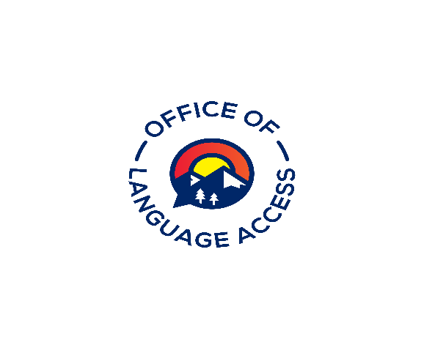
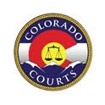

Office of Language Access - Continuing Education

Approval Request Form

All educational activities not included in the pre-approved list must be submitted to the compliance Panel a minimum of fifteen (15) days before the event takes place to receive approval and a CEAA number. All individual approval request forms must include supporting documentation such as a syllabus, agenda, or any other course material pertinent to the request. The Panel has discretion to deny a request

Course Information
Title Click or tap here to enter text.
Brief description of content
Click or tap here to enter text.
Speaker’s Name & Title (for conference or multi-day events, please list names and titles of speakers on separate sheet)
Click or tap here to enter text.
Date(s) of Activity  Click or tap here to enter text. | Time of Activity  (from)Click or tap here to enter text.(to)Click or tap here to enter text.
Number of continuing education points requested
(One point per hour of instruction; maximum of 12 points per event) Click or tap here to enter text.
Signature of Requesting Individual  Click or tap here to enter text. | Date  Click or tap here to enter text.

Approval (to be completed by the Language Access Administrator)
Reviewed by  Click or tap here to enter text. Date | CEAA#  Click or tap here to enter text. | Comments  Click or tap here to enter text.
Points Approved
Click or tap here to enter text.

Please submit this form via email to the Office of Language Access or Continuing Education Compliance Panel designee:
E-mail: continuingED@judicial.state.us

