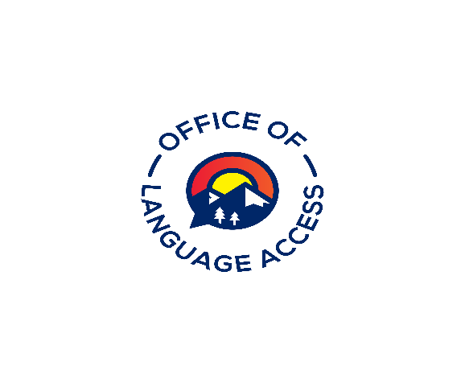

CEAA# Request form for Group and Individual Studies
Interpreters must submit all group and individual study request forms at least 30 days to continuingED@judicial.state.co.us prior to the starting date of the course. Together with the request form, the group or individual must provide a document with four learning goals they hope to achieve upon completion of the study. The request should include means by which the group/individual will achieve these goals (i.e., type and scope of work, resources to consult, people to interview, or workshops to attend) and the method by which they will demonstrate that their goals and objectives have been met. Submission of a one-page summary is required once the study has been finalized. An interpreter can receive a maximum of six (6) continuing education credit hours per compliance period for individual or group study
Course Information
Title Click or tap here to enter text.
Brief description of content
Click or tap here to enter text.
Participant’s Name/s
Click or tap here to enter text.
Date(s) of Activity or number of occurrences  Click or tap here to enter text. | Time of Activity  (from)Click or tap here to enter text.(to)Click or tap here to enter text.
Number of continuing education points requested
(Maximum of 6 points per review period) Click or tap here to enter text.
Signature of Requesting Individual  Click or tap here to enter text. | Date  Click or tap here to enter text.

Approval (to be completed by the Language Access Administrator)
Reviewed by  Click or tap here to enter text. Date | CEAA#  Click or tap here to enter text. | Comments  Click or tap here to enter text.
Points Approved
Click or tap here to enter text.

