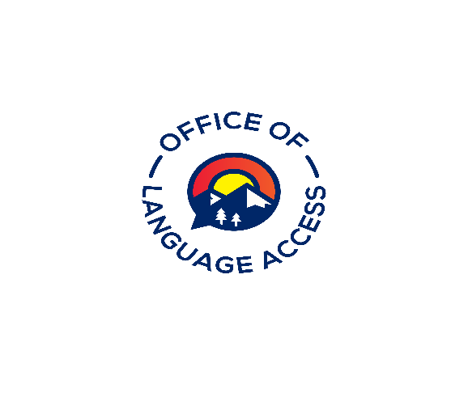

Office of Language Access - Continuing Education

CEAA# Request form

If you’ve taken a course with an approved provider and don’t see that course on our list of pre-approved courses, please fill out this form and submit it to our office. Once the form has been reviewed, a CEAA# will be issued and the signed form will be returned to the sender via email.

Course Information
Title Click or tap here to enter text.
Brief description of content
Click or tap here to enter text.
Speaker’s Name & Title (for conference or multi-day events, please list names and titles of speakers on separate sheet)
Click or tap here to enter text.
Will this course be offered multiple times during the compliance period? Yes ☐ No☐ | If yes, how many times between February 1, 2022 to January 31, 2024?  Click or tap here to enter text.
Date(s) of Activity  Click or tap here to enter text. | Time of Activity  (from)Click or tap here to enter text.(to)Click or tap here to enter text.
Number of continuing education points requested
(One point per hour of instruction; maximum of 12 points per event) Click or tap here to enter text.
Signature of Requesting Individual  Click or tap here to enter text. | Date  Click or tap here to enter text.

Approval (to be completed by the Language Access Administrator)
Reviewed by  Click or tap here to enter text. Date | CEAA#  Click or tap here to enter text. | Comments  Click or tap here to enter text.
Points Approved
Click or tap here to enter text.

Please submit this form via email to the Office of Language Access or Continuing Education Compliance Panel designee:
E-mail: continuingED@judicial.state.us

