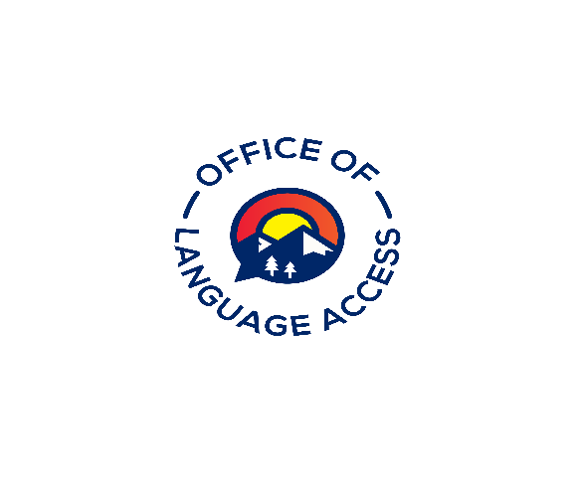
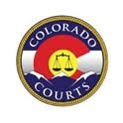

Approval Request Form for Volunteer Hours

Interpreters must submit all Approval Request Forms for Volunteer Hours at least 15 days to continuingED@judicial.state.co.us before the starting date of the event. Together with a flyer or link to the event. An interpreter can receive a maximum of four (4) continuing education credit hours per compliance period for volunteer hours.
Course Information
Name of Organization/Sponsor Click or tap here to enter text.
Brief description of event
Click or tap here to enter text.
Event’s Address Click or tap here to enter text.
Event’s Contact Information Click or tap here to enter text.
Participant’s Name
Click or tap here to enter text.
Date(s) the participant will volunteer  Click or tap here to enter text. | Time of Activity  (from) Click or tap here to enter text.(to)Click or tap here to enter text.
Number of continuing education points requested
(Maximum of 4 points per review period) Click or tap here to enter text.
Signature of Requesting Individual  Click or tap here to enter text. | Date  Click or tap here to enter text.

Approval (to be completed by the Language Access Administrator)
Reviewed by  Click or tap here to enter text. Date | CEAA#  Click or tap here to enter text. | Comments  Click or tap here to enter text.
Points Approved
Click or tap here to enter text.

