Virtual Courtroom | Yuma County Courtroom Division E
All virtual appearances shall be governed by Colorado Chief Justice Directive 23-03. In attempt to preserve the dignity of the court, preserve the decorum and solemnity of the courtroom, and the efficient processing of cases on the docket, the Court places the following restrictions on virtual appearances before Division 1, in accordance with CJD 23-03:
- Parties shall appear in person at all Presumptively In-Person Appearances unless the court finds good cause pursuant to CJD 24-03.
- You will NOT be permitted to appear virtually if you have an outstanding warrant or orders (E.g., fingerprints, protection orders, firearms receipts, et cetera).
- DO NOT UNMUTE your microphone until your case is called.
- Virtual appearance requires video/camera to be enabled and functional and the listed name must be yours and accurate.
- Parties shall be dressed appropriately for court appearance, removing hats, sunglasses, et cetera.
- There shall be no distractions in the background, including, but not limited to, non-parties, pets, and excessive movement or noise.
- Parties shall not be performing any other tasks, including driving, eating, smoking, et cetera, while waiting for their case to be called and throughout their appearance.
- Parties shall be respectful, shall not interrupt the proceeding, and shall not use gestures or foul language.
- There shall be NO RECORDING, STREAMING, or PHOTOGRAPHY of any courtroom proceeding, with violators facing contempt of court.
- This virtual courtroom is for parties and witnesses only—any others will be removed. The public must view proceedings through the state’s judicial website.
Violation of these policies will result in immediate removal from the hearing and the inability to appear virtually in the future.
Webex Conference Site: https://judicial.webex.com/meet/d13-all-dive

Meeting number (access code): 2663 765 2595

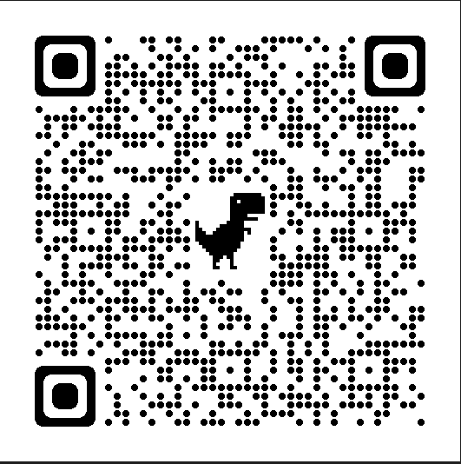

Join by telephone (audio only) [requires a court order]:
Webex Conference Number: 1+(415) 655-0001
Access Code: 2663 765 2595#

