8th Judicial District Court Resource Center
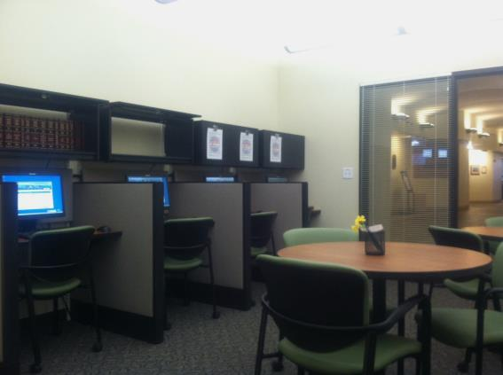
The Court Resource Center is available to assist self-represented parties involved in legal proceedings in the 8th Judicial District. The Court Resource Center is located on the first floor of the Larimer County Justice Center, next to the Clerk of Court Office, at 201 Laporte Avenue, Fort Collins, Colorado. The Self-Represented Litigant Coordinator is on staff at the Court Resource Center to provide parties without attorneys free procedural information and will also assist in completing forms. The staff can answer questions about forms, the legal system, court procedure and court processes but CANNOT provide legal advice. Public access computers are available for research and completing forms.
Hours:
Monday 8:00 a.m. – 4:00 p.m.
Tuesday 8:00 a.m. – 2:00 p.m.
Wednesday 8:00 a.m. – 4:00 p.m.
Thursday 8:00 a.m. – 2:00 p.m. and by appointment
Friday 8:00 a.m. – 4:00 p.m.
Pro Se clinics

1st and 3rd Tuesday of each month 3:00 p.m. to 5:00 p.m. Domestic Relations

Ask-a-Lawyer

2nd Tuesday of each month 3:00 p.m. to 5:00 p.m. (by appointment only)

To schedule an appointment, email 08CourtResourceCenter@judicial.state.co.us or visit the Court Resource Center during regular business hours.
How can the Court Resource Center help you?
Here are just a few ways the Court Resource Center can provide assistance to self-represented individuals:
We Can…
Locate and Access Forms
Look Up Orders
Check Your Case Status
Assist you with Filling Out Forms
Determine Which Form You May Need
Check Forms for Completeness
Provide General Information About Court Procedure

Self-Help Personnel are neutral information providers and will provide the same services and information to all parties in a case, if requested. In all cases, it is best to obtain the assistance of your own lawyer, especially if your case contains significant or complicated issues.

