8th Judicial District Court Resource Center
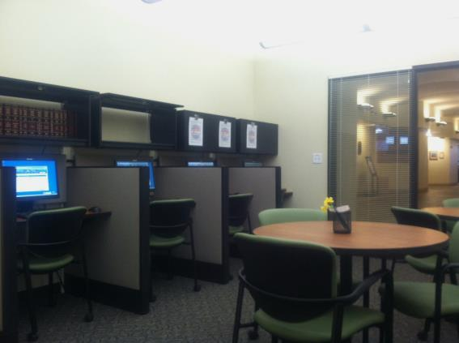
The Court Resource Center will be extending its hours of operation in the Fort Collins location and services will no longer be available in the Loveland location effective December 3, 2018. The Court Resource Center will be available to assist self-represented parties involved in legal proceedings in the 8th Judicial District and will provide parties without attorneys free procedural information and will also assist in completing forms. The staff can answer questions about forms, the legal system, court procedure and court processes but CANNOT provide legal advice. Public access computers will still be available for research and completing forms in the Loveland Jury Assembly Room in the Loveland County Courthouse located at 810 E 10th Street Loveland, CO.

The new Fort Collins Court Resource Center Hours effective December 3, 2018 will be:
Monday, Wednesday and Friday 8:00 am – 4:00 pm
Tuesdays 8:00 am – 2:00 pm
Thursdays 8:00 am -2:00pm and by appointment only
The Court Resource Center is located at:
Larimer County Justice Center
201 La Porte Ave, Suite 100
Fort Collins, CO 80521

How can the Court Resource Center help you?
Here are just a few ways the Court Resource Center can provide assistance to self-represented individuals:
We Can…
Locate and Access Forms
Look Up Orders
Check Your Case Status
Assist you with Filling Out Forms
Determine Which Form You May Need
Check Forms for Completeness
Provide General Information About Court Procedure

Court Resource Center Personnel are neutral information providers and will provide the same services and information to all parties in a case, if requested. In all cases, it is best to obtain the assistance of your own lawyer, especially if your case contains significant or complicated issues.

