PRESIDING JUVENILE JUDGE ORDER 2015-2
STATE OF COLORADO
FIRST JUDICIAL DISTRICT
_______________________________________________________________________________________

AMENDED YOUTH IN COURT ORDER
________________________________________________________________________________________________________________________________________________________________
WHEREAS THE PERMANENCY COMMITTEE OF THE 1st JUDICIAL DISTRICT BEST PRACTICE TEAM IDENITIFED A NEED TO ESTABLISH A PROTCOL TO ENCOURAGE YOUTH TO APPEAR IN COURT;

WHEREAS §19-3-702(3.7) C.R.S. MANDATES THAT “THE COURT CONDUCTING THE PERMANENCY HEARING SHALL CONSULT WITH THE CHILD; IN AN AGE-APPROPRIATE MANNER REGARDING THE CHILD’S PERMANENCY PLAN”;

WHEREAS THE PERMANENCY COMMITTEE REVIEWED LITERATURE AND POLICY AND SOUGHT TO ADOPT A PROTOCOL THAT IS CONSISTENT WITH BEST PRACTICE AS DETERMINED BY SUCH ORGANIZATIONS AS THE NATIONAL COUNCIL OF JUVENILE AND FAMILY COURT JUDGES (NCJFCJ);

WHEREAS THE NCJFCJ HAS ADOPTED A POLICY THAT CHILDREN OF ALL AGES SHOULD COME TO COURT UNLESS IT IS DECIDED BY THE JUDICIAL OFFICER BASED ON INFORMATION PROVIDED BY CASE PARTICIPANTS THAT IT IS NOT SAFE OR APPROPRIATE FOR THE CHILD TO COME TO COURT;

IT IS HEREBY RESOLVED THAT:

Guardian ad Litems (GALs) shall meet with their client prior to Permanency Planning hearings in order to prepare the child/youth for court and also assess whether the youth’s participation is in his or her best interests;

Children/youth participation in other hearings and proceedings including Disposition, Allocation of Parental Responsibilities hearings and Case Management Conferences when appropriate is also encouraged.

There is no minimum age for participation. The presumption will be that the child/youth will be allowed and encouraged to come to court. Evidence to rebut the presumption can be presented by the GAL, Caseworker or CASA, and may include but is not limited to, such reasons as young age of the child/youth, mental state of the child/youth, developmental disability of the child/youth, or preference on the child’s/youth’s part to participate in an alternative manner.

GALs, CASA and caseworkers will work together to ensure that the children/youth know they have a right to be heard by the court. Children/youth will be told that they have several options for communication, including actual court attendance, letter, fax, or email to the court, or having the GAL speak on their behalf. In the case where the child/youth wants to speak to the judge but not during a formal hearing or docket, the GAL shall file a motion to that effect or provide notice on the record. The conversation between the child/youth and the Court shall take place on the record. The judicial officer shall provide a summary of the conversation on the record or in writing at the time of the next regularly scheduled hearing in the matter.

If the GAL, caseworker and CASA disagree on the issue of whether a child/youth should attend a hearing, the GAL shall make the final decision.

If a child/youth does not participate in a permanency planning hearing, the Court will inquire as to whether the child/youth was consulted and what his/her position is. The GAL will address the child’s/youth’s position in a written or oral report. The GAL shall also be prepared to explain to the Court why the child/youth is not present in Court.

The GAL and the caseworker shall be responsible for working with the treatment team to arrange for the child’s/youth’s transportation. CASA volunteers may be considered for transportation, even in cases where no CASA is assigned to the case. (The protocol for requesting and receiving assistance from CASA is reduced to writing and attached to this Order as Exhibit 1).

CASA volunteers may assist with children/youth waiting for their hearings. Cases where a child/youth is present will have priority in being heard. The order of priority in calling cases on a dependency and neglect docket will be: incarcerated, interpreter, child/youth, all other cases.

The Bench shall make it a priority to accommodate the appearance of youth/children in Court.

Finally, as this is a statutory requirement, it necessitates ongoing communication about issues regarding this protocol that may arise in the future. It is the expectation of the Court that all stakeholders shall continue to monitor and adapt to the changing needs of our community and the children and families we serve in order to better incorporate the youth voice in this process. .

Effective on the 1st day of July, 2015.

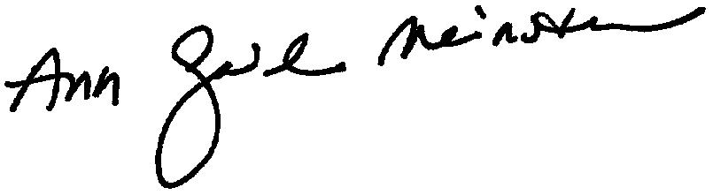
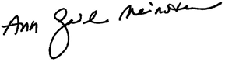 ___________________________________ Ann Gail Meinster
Presiding Juvenile Judge
First Judicial District

