District Court, Grand County, Colorado  Court Address: 307 Moffat Ave, PO Box 192  Hot Sulphur Springs, CO 80451  Phone Number: 970-725-3357  ____________________________________________________________  Petitioner:  Co-Petitioner/Respondent: | COURT USE ONLY  Case Number:
DOMESTIC RELATIONS
CASE MANAGEMENT ORDER (Amended 05-15)

This order reflects the procedures to be followed in domestic relations cases in the 14th Judicial District.

INITIAL STATUS CONFERENCES
1. The Court orders the parties to attend an initial status conference at 307 Moffat Ave, Hot Sulphur Springs, Colorado on: _________(date) at ________ (time) with Susan Ritschard, Family Court Facilitator. Parties may appear in person or by telephone on the Family Court Conference Line 1-800-444-2801 use code 6009413.

2. The initial status conference must take place within 42 days of filing. The person filing the Petition is responsible for serving the other party with a copy of this case management order.

3. The purpose of the conference is (1) to review the case process, (2) to establish a schedule for completing Court requirements, and (3) to set the next event in your case.

4. The Facilitator or Judge does not and cannot represent either party or give legal advice. The Facilitator and/or Judge will not prepare documents for either party.

5. All parties who file an affidavit for decree without appearance with all required documents before the initial status conference shall be excused from the conference. However, the Facilitator may contact the parties to provide additional information if necessary.

6. If both parties are represented by attorneys, the attorneys may submit a Stipulated Case Management Plan signed by attorneys and the parties. If the Stipulated Case Management Plan, Financial Affidavit, and Certificate of Compliance are filed before the initial status conference, the parties are excused from the conference.

GENERAL INFORMATION AND HELP

7. The Court encourages but does not require you to use an attorney in your domestic relations case. If you wish to learn if you qualify for free legal assistance, call Legal Services at 1-800-521-6968.

8. If your case involves domestic violence, the Court encourages you to obtain an assessment, counseling or other support services for your family. Financial assistance may be available for those who cannot afford such services. Attached is a list of services available in the Fourteenth Judicial District.

9. Forms are available for self-represented parties to use. The Court Clerk’s office sells packets containing the most commonly used forms for $25.00. The Colorado Judicial Branch website at www.courts.state.co.us makes all forms available to download for free.
10 If you are representing yourself, a Self-Help Coordinator is available to assist you with general questions, paperwork, resources, and forms related to your case and can help you understand court statutes, rules, policies, and procedures. The Self-Help Coordinator is a neutral information provider only; the Coordinator cannot give you legal advice and the Coordinator cannot tell you your legal rights or remedies. For more information, or to set an appointment, contact your local combined court in the 14th Judicial District.

http://www.courts.state.co.us/Courts/District/Index.cfm?District_ID=14

Moffat County | 221 W. Victory Way  Suite 300  Craig, CO | (970) 824-8254
Routt County | 1955 Shield Drive  Steamboat Springs, CO | (970) 879-5020
Grand County | 307 Moffat Avenue  Hot Sulphur Springs, CO | (970) 725-3357

FINANCIAL DISCLOSURES

11. The parties and counsel shall provide each other full and complete disclosure of all relevant financial documents as quickly as possible, but no later than 42 days from the date of service or, in the case of co-petitioners, from the date of filing. See Colorado Rules of Civil Procedure, Rule 16.2(e)(2), Form 35.1 for guidance (JDF 1125).

12. Each party must file with the Court the form entitled “Sworn Financial Statement” (JDF 1111). Once the parties complete disclosure, the parties must file with the Court the form entitled “Certificate of Compliance.” (JDF 1104).

13. All parties with children must file the appropriate child support worksheet. (JDF 1820 or JDF 1821).

14. Effective January 1, 2014, before a court can approve any Separation Agreement for any marriage at least three years in length, the parties must satisfy the court that they are familiar with the maintenance (spousal support) guidelines found at C.R.S. 14-10-114. These guidelines apply to all divorce cases and a free program to calculate maintenance can be found at http://www.familylawsoftware.com/download_client_edition_co.html.

15. For procedures on conducting discovery and using expert witnesses, see Rule 16.2(f) & (g).

PARENTING CLASS

16. Parties with minor children must attend a Parent Information Course. Attached to this order are the class schedules for Routt and Moffat Counties. For updated information, please contact the Clerk of Court in your county.

17. If you live outside the Fourteenth Judicial District, contact the local state court in your area for information on the next available parenting course for parents going through dissolution of marriage or allocation of parental responsibilities proceedings. You must file a motion with the Court for permission to attend such a course.

18. Any parent who does not participate in the parent information program without having obtained a waiver from the Court may be subject to a fine, jail sentence, or other contempt penalty.

19. The court, in its discretion, may order parents to attend an additional intensive training in parent to parent communication. The three-part ten-hour course teaches well-coordinated parenting.
MEDIATION

20. Mediation is required before a contested final orders hearing is scheduled. The court, in its discretion, may order the parties to mediation early on in the case. The parties may use any mediator of their choosing or may attend mediation with the mediator contracted with the Fourteenth Judicial District. Attached is a list of the contract mediators.

21. Upon motion of a party, the Court may issue a waiver if it determines that the case is not appropriate for mediation because of physical or psychological abuse. (See JDF 608/609)

MOTIONS
22. Motions that may be filed with the Court are listed in Rule 16.2(c)(4)(A). Other motions must first be approved by the Court at a status conference or in an emergency upon order of the Court.

23. Motions for temporary orders may be filed at any time after attendance at a status conference with the Family Court Facilitator or Judge if the parties cannot otherwise agree. The Court may schedule an offer of proof hearing on Temporary Orders for up to 45 minutes at any time after the initial status conference.

CONTESTED FINAL ORDERS HEARING

24. If both parties do not have counsel and they are requesting a contested final orders hearing, they must each file with the Court a brief statement of the disputed issues, a list of their witnesses, and their exhibits including updated financial affidavits. The statement, list of witnesses, and exhibits must be mailed to the other party at least 10 days before the hearing.

25. If at least one party is represented by counsel, the parties must file a Trial Management Certificate 10 days before the hearing. The parties must exchange exhibits at least 10 days before hearing. The Trial Management Certificate shall include those items described in Rule 16.2(h)(2).

26. The Court may exclude witnesses or exhibits not disclosed on time by the parties.

It is so ordered.
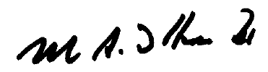
Dated ________________________________ _______________________________________

Attachments (3):
Domestic Violence Advisement
Parent Information Class Schedule Grand County
Mediator List

CERTIFICATE OF SERVICE

I hereby certify that a true and accurate copy of the Domestic Relations Case Management Order was served on the other party by:

_____ Hand delivered to:
_____ Delivered via attorney tray to: ________________________
_____ Mailed to: ________________________
_____ E-Filed
Date: ____________
Court Judicial Assistant

ADVISEMENT OF AVAILABLE DOMESTIC VIOLENCE SERVICES

Domestic violence is a pervasive problem in society. A significant portion of domestic
violence occurs in or near the home. Research shows that children in a home where domestic violence occurs are at greater risk of emotional, psychological, and physical harm. Studies have found that 80%-90% of the children living in homes with domestic violence are aware of the violence. Emerging research has established that these children are at greater risk of the following: psychological, social, and behavioral problems; higher rates of academic problems; more physical illnesses, particularly stress-associated disorders; and a greater propensity to exhibit aggressive and violent behavior, sometimes carrying violent and violence-tolerant roles to their adult relationships. Studies have also noted that children are affected to varying degrees by witnessing violence in the home, and each child should be assessed on an independent basis. Colorado Revised Statutes Section 14-10-123.6

If your case involves domestic violence, you are strongly encouraged to obtain an assessment, counseling, or other services for your family. If you are on a limited income or cannot afford such services, financial assistance may be available to cover some or all of the costs. Call the following for domestic violence services and potential financial resources available in your area:

GRAND COUNTY MOFFAT COUNTY

Advocates Victim Assistance Team Advocates
(970)725-3442 (970)824-9709
(970)725-3412 (24-hour crisis line) (970)824-2400 (24-hour crisis line)

Grand County Dept. of Social Services Moffat County Dept. of Social Services
(970)725-3331 (970)824-8282
ROUTT COUNTY

Advocates Against Battering and Abuse
(970)879-2034
(970)879-8888 (24-hour crisis line)

Routt County Dept. of Human Services
(970)879-1540

The organizations listed above may provide domestic violence assistance or refer out to other individuals or organizations to suit a particular need. Other providers may be found in the local telephone book yellow pages under the listing “Counselors.”

If your children participate in assessments or counseling related to domestic violence, the court will apportion the costs of such services between the parties, as it deems appropriate.

P. O. Box 773117
Steamboat Springs, CO 80477
Telephone: 970-879-5020 ext. 27
Office Located in Steamboat Springs

STATE OF COLORADO

Fourteenth Judicial District
Office of the Court Facilitator

MANDATORY MEDIATION

Effective January 1, 2005
the following mediators have been contracted by
the Judicial District for work in Domestic Relations cases:

Routt County: Barbara Phillips
(970) 879-7637

Moffat County: Barbara Phillips
(970) 879-7637

Grand County: Sara Evanczyk (970) 668-0912 or email at sarae@saefamilylaw.com
Tammy Stewart (970) 819-9176
Tracy James (303) 220-1969 or mtracyjames@gmail.com

The Judicial Department establishes costs associated with mediation. Information regarding these costs is available from any of the above individuals. If you prefer to use a qualified mediator of your own choosing you may do so consistent with whatever guidelines the court may establish (if any). Please note that private sector mediators are not bound by cost guidelines established by the Judicial Department.

MANDATORY PARENT INFORMATION CLASS

The lists of class dates and class instructors for Routt and Moffat Counties are provided separately. Classes for Grand County are scheduled to meet demand. The instructor’s for Grand County Parent information classes are:

Andy Thomasson, LCSW, CAC II
970-531-6173
www.lunacounseling.org

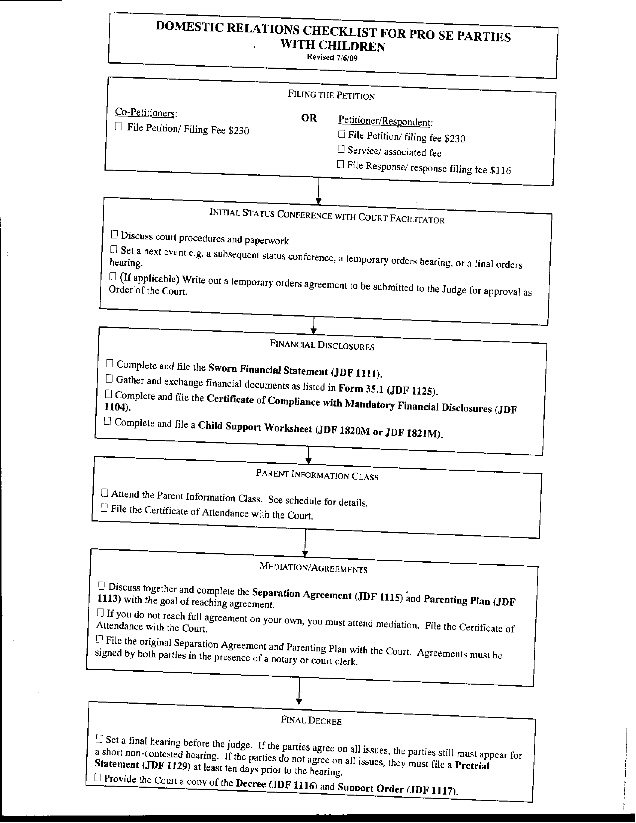
DOMESTIC RELATIONS CHECKLIST FOR PRO SE PARTIES
WITH NO CHILDREN
Revised 7/7/09
Filing the Petition

Co-Petitioners: OR Petitioner/Respondent:
File Petition / filing fee $230 File Petition/ filing fee $230
Service/ Associated fee
File Response/ filing fee $116

Initial Status Conference with Court Facilitator

Discuss procedures and paperwork
Set a next event e.g. a subsequent status conference, a temporary orders hearing, or a final orders hearing.
(If applicable) Write out a temporary orders agreement to be submitted to the Judge for approval as an Order of the Court.
Financial Disclosures

Complete and file the Sworn Financial Statement (JDF 1111)
Gather and exchange Financial Documents as listed in Form 35.1 (JDF 1125)
Complete and file the Certificate of Compliance with Mandatory Financial Disclosures (JDF 1104)

Mediation/Separation Agreement

Discuss and complete the Separation Agreement (JDF 1115) with the goal of reaching agreement
If you do not reach full agreement on your own, you must attend mediation. File a Certificate of Attendance with the Court.
File the original Separation Agreement with the Court. The agreement must be signed by both parties in the presence of a notary or court clerk.

Final Decree If A Complete Separation Agreement Is Filed With The Court

File an Affidavit for Decree without Appearance of Parties (JDF 1201) signed by both parties in presence of a notary or a court clerk.
Provide the Court a copy of the Decree (JDF 1116), and self-addressed stamped envelopes.

Final Decree If No Separation Agreement (or a Partial Separation Agreement) Is Filed With The Court.

Set a contested hearing in front of the judge.
File a Pretrial Statement (JDF 1129) at least 10 days prior to the hearing.
Provide the Court a copy of the Decree (JDF 1116). Parties will receive copies of the signed decree at the hearing.
