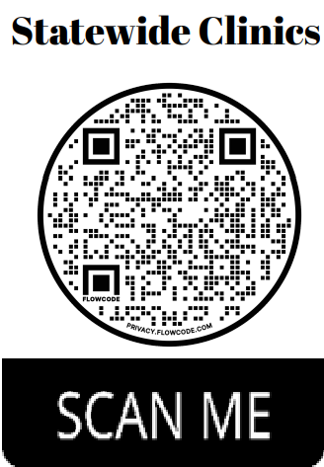
2 0 2 4 L E G A L C L I N I C S H O S T E D B Y S T A T E W I D E A C C E S S T O J U S T I C E C O M M I T T E E S

- Virtual Clinics are through WebEx
- https://judicial.webex.com/meet/d29-all-statewideclinics
Access code just in case: 2595 955 0673
- Join by phone
+1-415-655-0001 US Toll
+1-720-650-7664 United States Toll (Denver)
Access code: 2595 955 0673

- In person attendance may be available through the local Courthouses or Libraries. Please contact your local Self-Help Coordinator for more information.
- https://www.courts.state.co.us/judicialnet/files/Files/jbits/SOPs/SRLC/ Contact%20list%20for%20public(2).pdf

Divorce/Custody
-PRE-DECREE

WHEN: The 2nd Wednesday of the month from 12:00
p.m. to 1:30 p.m.

WHERE: Virtually (WebEx) No registration needed

DATES ARE BELOW:
January 10
February 14
March 13
April 10
May 8
June 12 July 10 August 14
September 11 October 9 November 13 December 11
How to Collect a Judgment
WHEN: The 1st Wednesday of the month at 5:30 p.m.

WHERE: Virtually (Zoom))- You must register by the Monday before by emailing: 01SelfHelp@judicial.state.co.us

DATES ARE BELOW:
January
February 7 March 6 April 3 May 1 June 5
July
August 7
September 4 October 2 November 6 December 4
Sealing of Records
WHEN: The 3rd Wednesday of the month from 12:00
p.m. to 1:30 p.m.

WHERE: Virtually (WebEx) No registration needed

DATES ARE BELOW:
January 17
February 21 March 20 April 17
May 15
June 19
July 17
August 21 September 18 October 16 November 20 December 18
Probate/Estate
WHEN: Once a month on Monday from 12:00 p.m. to 1:30 p.m.

WHERE: Virtually (WebEx) No registration needed

DATES ARE BELOW:
January 22
February 26 March 18 April 15
May 20
June 17
July 15
August 19 September 16 October 21 November 18 December 16

