Correctional Treatment Board

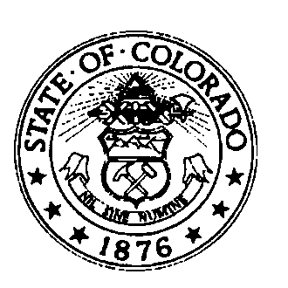
April 18, 2017
Division of Criminal Justice, 3rd Floor Conference Room
2:30pm-4:30pm

AGENDA

- Administrative Items
  - Approve minutes
  - Approve FY18 meeting schedule
  - Discuss time proximity and agenda availability

- CCJC Conference Update

- Program presentation schedule (CAM, JBBS, PSC, ACA)

- Budget

- May meeting date and location

- May meeting agenda requests

- Updates from Board Member or visitors

Next Meetings:
Tuesday, May 16, 2017
Tuesday, June 20, 2017

All meetings are from 2:30-4:30pm at the Division of Criminal Justice, 710 Kipling Street 3rd Floor Conference Room.

Meetings and minutes and other documents are posted on the Correctional Treatment Board’s website which is located on the Colorado Judicial Branch website under the Administration, Probation Services tab:

http://www.courts.state.co.us/Administration/Unit.cfm?Unit=ctb

Board Co-Chairman
Deborah Duran,
Community Parole Manager
Division of Adult Parole,
Department of Corrections

Board Co-Chairman
David Walcher, Sheriff
Arapahoe County Sheriff’s Office
County Sheriffs of Colorado

Board Members
Jim Bullock, District Attorney
16th Judicial District
Colorado District Attorney’s Council

Jagruti Shah, Interim Director
Criminal Justice Services
Division of Community Behavioral Health
Department of Human Services

Brian Connors, Chief Deputy
State Public Defender’s Office

Eileen Kinney, Senior Manager
Division of Probation Services
State Court Administrator’s Office

Joe Thome, Director
Division of Criminal Justice
Department of Public Safety

Board Staff
Marcy Becker
Division of Probation Services
Colorado Judicial Branch

_______________________________________________
Board Staff Contact Information:
1300 Broadway, 11th Floor, Denver, Co 80203
(720) 625-5771

