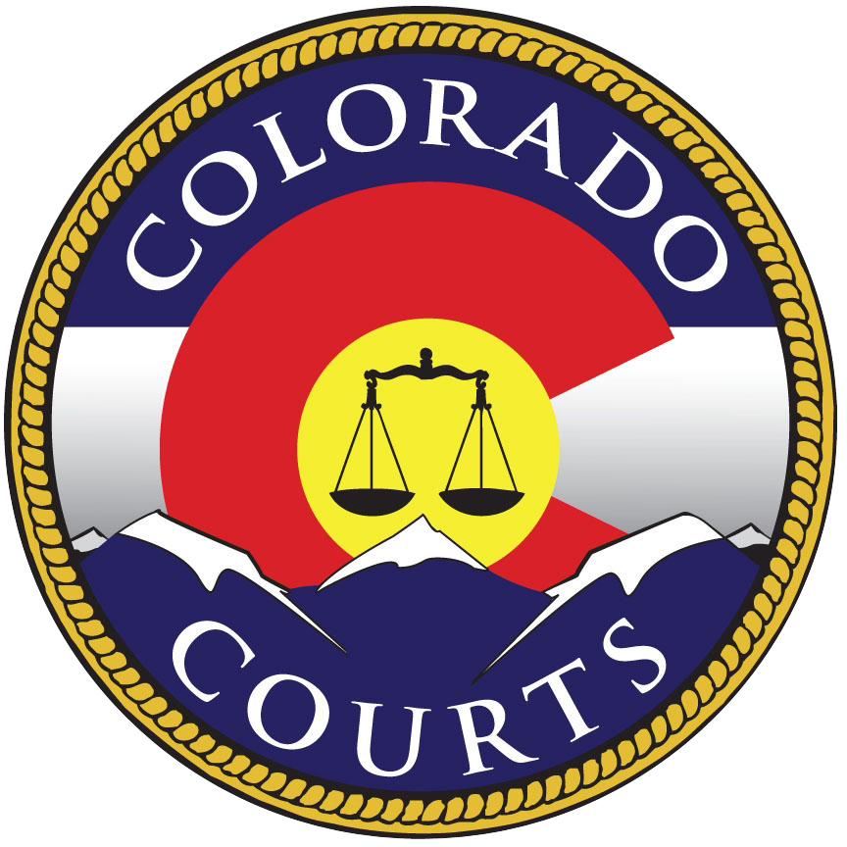

***Colorado Courts and Probation***

***FY 2015 Strategic Performance Plan***

Trust in the rule of law distinguishes our society from many others around the world. The legitimacy of government depends on the fair, impartial, and reliable administration of the laws. When citizens who go to court feel they are treated with dignity and respect, research shows that they trust the court system and are more likely to understand, appreciate, and follow court orders. The term "procedural fairness" has been coined by researchers to refer to the perception of fairness by those accessing the courts.

Courts serve the people of the state by resolving disputes, protecting individual rights, and delivering justice in criminal and civil cases. To ensure a just society, courts must tailor the fair, effective, and efficient delivery of justice to fit each individual case. This mission requires us not only to reach a fair and just outcome but also to do so in a way that is perceived as being fair to all sides. The perception of fairness is as important as the fairness of the outcome.

For citizens to trust the judicial system they must believe that justice is truly for all. The courts are a fundamental government service and should be easily accessible by the public. Today, as historic events unfold in many parts of the world, we see that where a fair and open judicial system does not exist, citizens are alienated from their governments and instability occurs.

**Mission**

**The Colorado Judicial Branch, comprised of our state Courts and Probation Services, provides a fair and impartial system of justice that:**

* **Protects constitutional and statutory rights and liberties.**
* **Assures equal access.**
* **Provides fair, timely and constructive resolution of cases.**
* **Enhances community welfare and public safety.**

**STATUTORY AUTHORITY:** The statutory authority for Colorado’s Courts is at Article VI, Colo. Const. and §13-4-101, C.R.S.; and for Probation Services is at 18-1.3-201 and 18-1.3-202.

***Major Functions of the Department***

***COLORADO SUPREME COURT***

The Colorado Supreme Court is the state's court of last resort. Its decisions are binding on all other Colorado state courts. The Supreme Court is composed of seven justices who serve ten-year terms, and the Chief Justice is selected from the membership of justices. The Chief Justice also serves as the executive head of the Colorado Judicial System and is the ex-officio chair of the Supreme Court Nominating Commission. The Chief Justice appoints the Chief Judge of the Court of Appeals and the Chief Judge of each of the state's 22 judicial districts and is vested with the authority to assign judges (active or retired) to perform judicial duties.

Requests to review decisions of the Colorado Court of Appeals constitute a majority of the Supreme Court's filings. The Supreme Court also has direct appellate jurisdiction over cases in which a statute has been held to be unconstitutional, cases involving decisions of the Public Utilities Commission, writs of habeas corpus, cases involving adjudication of water rights, summary proceedings initiated under the Election Code, and prosecutorial appeals concerning search and seizure questions in pending criminal proceedings. All of these appeals are filed directly with the Supreme Court, and, in these cases bypass the Court of Appeals. The Supreme Court also has exclusive jurisdiction to promulgate rules governing practice and procedure in civil and criminal actions.

Colorado's attorneys are licensed and disciplined by the Supreme Court. The court's attorney regulation system, funded by attorney registration fees, polices the profession. In addition, the court oversees the State Court Administrator, Board of Continuing Legal Education, Board of Law Examiners, Commission on Judicial Discipline, and Unauthorized Practice of Law Committee.

**COLORADO COURT OF APPEALS**

The Colorado Court of Appeals is the state's intermediate appellate court and consists of 22 judges who serve eight-year terms. The Court sits in three-member divisions to decide cases. The mission of the Court of Appeals is to provide the citizens of Colorado with clear, impartial, and timely resolutions of appealed orders and judgments as provided by law. The Court of Appeals has initial jurisdiction, with exceptions, over appeals from the Colorado District Courts, Denver Probate Court, and Denver Juvenile Court. In addition, the Court of Appeals has appellate jurisdiction over decisions originating from a number of state administrative boards and agencies. Reviews of the Court of Appeals’ decisions are directed to the Colorado Supreme Court.

**COLORADO TRIAL COURTS**

Established pursuant to Article VI of the Colorado Constitution, Colorado’s state trial courts consist of county courts, district courts, and water courts.

Colorado’s district courts serve citizens of each county in the state. There are currently 175 district judges serving Colorado’s 22 judicial districts. District judges preside over felony criminal matters, civil claims in any amount, juvenile matters (including adoption, dependency and neglect matters, juvenile delinquency, and paternity actions), probate, mental health, divorce proceedings, and water cases. Additionally, district judges handle appeals from Colorado municipal and county courts, and review decisions of some administrative boards and agencies.

Colorado’s county courts serve the citizens of each county in the state as well. County judges handle cases involving serious public safety issues such as misdemeanor cases, felony advisements, setting bonds, and preliminary hearings. There are 115 county court judges. County judges also issue restraining orders in cases involving domestic violence arrest, issue search warrants, and preside over traffic cases and civil actions involving no more than $15,000.

The Water Right Determination and Administration Act of 1969 created seven water divisions according to drainage patterns of various rivers in Colorado. Each water division is staffed with a division engineer, appointed by the state engineer; a water judge, appointed by the Supreme Court; a water referee, appointed by the water judge; and a water clerk, assigned by the district court. Water judges are district judges appointed by the Supreme Court and have jurisdiction in the determination of water rights, the use and administration of water, and all other water matters within the jurisdiction of the water divisions.

**PROBATION SERVICES**

Colorado Probation Services is committed to public safety, victim and community reparation through offender accountability, skill and competency development and services to the communities of Colorado.

Probation Services administers adult and juvenile probation within Colorado’s 22 judicial districts. This includes 23 probation departments with over 50 separate probation offices throughout the state. The Colorado Probation Statement of Common Ground, listed above, was developed to clearly identify the critical functions that unify all probation departments in carrying out their mission. Probation’s commitment to these practices requires the implementation of innovative approaches to offender assessments, supervision, victim involvement and services to the community. These probation departments strive to meet every part of the Statement of Common Ground on a daily basis.

**OFFICE OF THE STATE COURT ADMINISTRATOR**

Colorado Courts and Probation, with more than 300 judges and 3,500 support staff members, is centrally administered by the Chief Justice of the Supreme Court. To assist the Chief Justice, the Supreme Court appoints the State Court Administrator (SCA). Each of the State's 22 Judicial Districts also has a District Administrator and a Chief Probation Officer, and each of the 64 counties has a Clerk of Court.

The SCAO provides administrative support and services to the trial and appellate courts to assist them in providing the citizens of Colorado meaningful, speedy and economical forums to resolve disputes. It also supports the management of probation services to enhance public protection and offender rehabilitation.

In executing its constitutional and statutory duties, the office has the following functions: to provide administrative and technical support to the appellate courts, trial courts and probation; to provide centralized policy guidance; to develop and implement standards and guidelines; to serve as an advocate in obtaining necessary resources from the legislature; to provide services in an accurate, timely and equitable manner.

Innovative business processes and technologies are constantly under evaluation for possible introduction throughout the Branch in order to improve efficiency and to make the courts more accessible to the citizens of Colorado.

***Principle Strategies and Goals***

***PRINCIPLE 1: Provide equal access to the legal system and give all an opportunity to be heard.***

*Barriers to access range from difficulties navigating within the court and probation facilities to a lack of information on obtaining accommodations for people with disabilities or limited English proficiency to inadequate resources to assist self-represented parties with their procedural questions. Such barriers may compromise effective and meaningful access to the court system.*

***GOAL 1a. Identify and address barriers to effective participation.***

***GOAL 1b. Maintain safety in all court and probation facilities.***

***GOAL 1c.******Assist self-represented parties.***

***PRINCIPLE 2: Treat all with dignity, respect, and concern for their rights and cultural backgrounds, and without bias or appearance of bias.***

*As Colorado’s population continues to diversify, so does the population that participates in the court system. It is important that judges and judicial staff be aware of the values of a wide number of cultures, and, when appropriate, to make accommodations. Courts and Probation is working to ensure that the courts are free from both bias and the appearance of bias, meeting the needs of increasing numbers of self-represented litigants, remaining receptive to the needs of all constituents, ensuring that court procedures are fair and understandable, and providing culturally responsive programs and services.*

***GOAL 2a. Collect feedback from court users, victims of crime, and those on probation regarding their experience with court and probation services.***

***GOAL 2b.******Train all court and probation employees in communication, cultural competency*, *and customer service skills.***

***PRINCIPLE 3: Promote quality judicial decision-making and judicial leadership.***

*Court practices and case management procedures should be as uniform as practicable to avoid confusion and uncertainty. Courts and Probation must provide ongoing professional development, education, and training to address many concerns including the increasing complexity of court practices and procedures, the incorporation of evidence based practices, and the importance of procedural fairness in all court operations and interactions with the public. Maintaining professional excellence will promote public trust and confidence in the judicial system as a whole.*

***GOAL 3a. Employ effective case management strategies.***

***GOAL 3b. Incorporate evidence-based principles in judicial decision making.***

***GOAL 3c. Employ accountability methods that ensure that court orders are being enforced and monitored.***

***GOAL 3d. Develop systems that assure court-appointed persons are providing quality services.***

***GOAL 3e. Train and educate judicial officers on an ongoing basis.***

***GOAL 3f. Implement professional development and leadership programs for staff.***

***PRINCIPLE 4: Implement quality assessments and community supervision of adult and juvenile probationers to demonstrably enhance public safety and respect for victim rights.***

*The Division of Probation Services strives to reduce offender recidivism through the application of the Eight Principles of Effective Intervention. Probation Services promotes accountability and responsiveness in its enforcement of the court’s orders while affecting long-term behavior change in offenders.*

**GOAL 4a. Ensure the accuracy and efficiency of pre- and post-sentence assessments; and provide comprehensive assessment information to judicial officers to assist judicial officers in making more informed decisions, leading to improved and less costly outcomes.**

**GOAL 4b. Employ evidence-based practices in all applicable areas of probation.**

***PRINCIPLE 5: Cultivate public trust and confidence through the thoughtful stewardship of public resources.***

*In serving the people of Colorado, Courts and Probation must also exercise its constitutional and statutory authority and responsibility to plan for, direct, monitor, and support the business of the system and to account to the public for the system's performance. The fulfillment of this role is only possible when the other branches of government and the public have trust and confidence in the system. In order to retain that trust and confidence, the system must be accountable to the people it serves by providing a fair and open process, communicating clear and consistent expectations for all who participate in that process, and being good stewards of the resources appropriated to it for the fulfillment of its mission.*

**GOAL 5a. Utilize the most effective and cost-efficient methods to conduct the business of the courts and probation.**

**GOAL 5b. Employ new and enhanced technology solutions for managing judicial business.**

**GOAL 5c. Share information and data with other governmental entities and the public, while balancing privacy and security concerns.**

**GOAL 5d. Ensure transparency of court and probation services operations.**

**GOAL 5e. Maintain a strong and well-trained workforce.**

***Environmental Scan/Key Trends***

The principal strategies and goals have been developed in an effort to identify and meet the challenges faced by the Colorado Courts and Probation in an ever changing environment. Many factors impact the operations of Colorado’s courts and probation, including:

* Focus on procedural fairness
* Increased number of self-represented parties
* Economic factors
* Population growth
* Changes in demographics
  + Aging population
  + Increased number of residents speaking foreign languages
* Increased reliance on technology

***Focus on procedural fairness***

Citizens who use the court system should feel that they are treated fairly throughout their court experience, which is often referred to as procedural fairness. Procedural fairness is a critical part of understanding how the public interprets their experience with the court system and translates that experience into a subjective valuation of the court system as a whole. There are four basic expectations that encompass procedural fairness:

1. Voice: the ability to participate in the case by expressing one’s viewpoint;
2. Neutrality: consistently applied legal principles, unbiased decision makers, and a “transparency” about how decisions are made;
3. Respectful treatment: individuals are treated with dignity and their rights are protected; and
4. Trustworthy authorities: authorities are benevolent, caring, and sincerely trying to help the litigants—this trust is garnered by listening to individuals and by explaining or justifying decisions that address the litigants’ needs.

Research suggests that the public perception of procedural fairness is associated with higher levels of compliance with court orders and lower levels of recidivism. In fact, studies have shown that most people are in fact more willing to accept a negative outcome in their case if they feel that the decision was arrived at through a fair method. This does not mean that people are happy if they lose their case and fail to obtain the outcomes they desire. It does mean, however, that they are more willing to accept and abide by decisions when those decisions seem to have been made fairly. In addition, procedural fairness increases the public’s perception of the legitimacy of the process.

In order to gauge the level of procedural fairness within the courts, the Branch conducted a survey in every judicial district in the state from 2008 through 2013. The survey is a set of ten trial court performance measures developed by the National Center for State Courts that attempt to give court managers a balanced perspective on court operations. The purpose of the survey is to (1) rate the court user’s perceptions of the courts accessibility and its treatment of court users in terms of fairness, equality, and respect; (2) provide a general snapshot on how the public perceives access and fairness in the courts; and (3) establish a baseline of information so that the courts can evaluate current practices and create plans for more improved and efficient court practices. The following tables illustrate statewide survey results from 2010 and 2011, compared with 2012 and 2013.

***Increased number of self-represented parties***

One complicating factor in providing access to the court system is that a fairly dramatic shift has occurred over the past ten to fifteen years: citizens now generally expect to be able to fully participate in a court case without the services of an attorney. The court system, unfortunately, has not been able to keep up with the demand for providing services to self-represented parties, often referred to as pro se parties, particularly requests for one-on-one procedural assistance. The need for greater services to self-represented litigants has been expanded by the intersection of two forces: (1) a larger cultural shift in terms of a do-it-yourself society that proceeds through the court system without an attorney for either philosophical or economic reasons, and, (2) the fact that people who interact with the court system must be savvy in an increasingly internet-based justice system, which unfortunately has left many people far behind.

Data collected and analyzed by the State Court Administrator’s Office shows large increases in pro separties, particularly in domestic relations cases, which include child custody, child support and divorce proceedings. Over the last decade, a greater number of litigants are not represented by a lawyer. The number of domestic relations cases proceeding without an attorney has grown by 57 percent from 2001 through 2013. Between FY 2001 and FY 2013, total domestic relations cases have grown by 11 percent. In addition to domestic relations cases, probate cases have also seen growth in the number of self-represented litigants (an increase of 35 percent since FY 2009). This caseload growth, along with a marked increase in self-represented litigants, has put significant pressure on the trial courts.

When an attorney is not involved in a case, more resources are required to process a case by court staff. Self-represented parties strain the court system in several respects. They: (1) increase the amount of time necessary for clerks to handle the day-to-day business of the courts and put stress on the workforce; (2) often file the wrong documents or incomplete documents; (3) fail to properly prepare for the hearing or trial and bring the necessary evidence and/or witnesses; (4) do not understand why the clerk’s office cannot provide free legal advice; (5) often are not computer literate, so simply giving them a website address of where the information is located is not always sufficient; (6) frequently don’t have the capacity to print documents necessary for their cases; and, (7) lack access to the necessary state statutes, court rules, and policies and procedures necessary to properly handle their cases.

In order to address this issue, the trial courts across the state have recognized that ultimately it is the court that must take leadership in addressing the procedural needs of self-represented litigants. By streamlining processes and providing informational resources, courts have become better situated to face the challenges related to self-represented litigants. From FY 2013 through FY 2015, the General Assembly funded a total of thirty-two new FTE that focus solely on providing procedural support to self-represented litigants. These allocations have ensured that every judicial district has at least a part-time employee to help address the needs of self-represented litigants at the local level.

***Economic Factors***

During periods of economic change, the courts see changes in the types and numbers of certain case filings. Economic challenges in certain sectors have contributed to an increased number of debt collection actions in county court along with foreclosures and tax liens in district court. Each of these case types have grown significantly in the last decade as illustrated below:

|  |  |  |  |
| --- | --- | --- | --- |
|  | **Year Case Filed** | |  |
| **Case Type** | **FY 2003** | **FY 2013** | **Percent Change** |
| Foreclosures | 14,837 | 20,399 | 37% |
| Tax Liens | 4,234 | 62,945 | 1,387% |
| Debt Collections in County Court | 105,403 | 118,734 | 13% |
| **Total** | **124,474** | **202,078** | **62%** |

These are also the case types that produce much of the revenue to Courts have come to rely on to fund basic operations over the past decade. During economic downturns, Court appropriations came to rely more heavily on filing fees. As the economy improves, these cases have begun to decline, putting significant strain on the Branch’s finances. As this trend continues, cash funded programs have begun to restrict expenditures (i.e. Courthouse Security, Family Friendly Courts) or are now needing general fund help to maintain program operations (i.e. Judicial Performance).

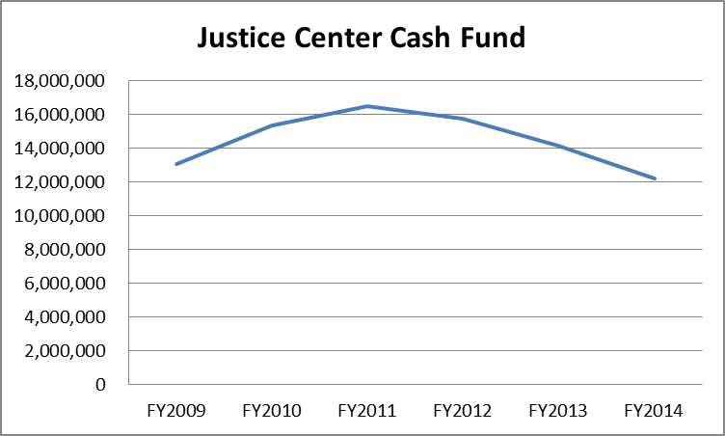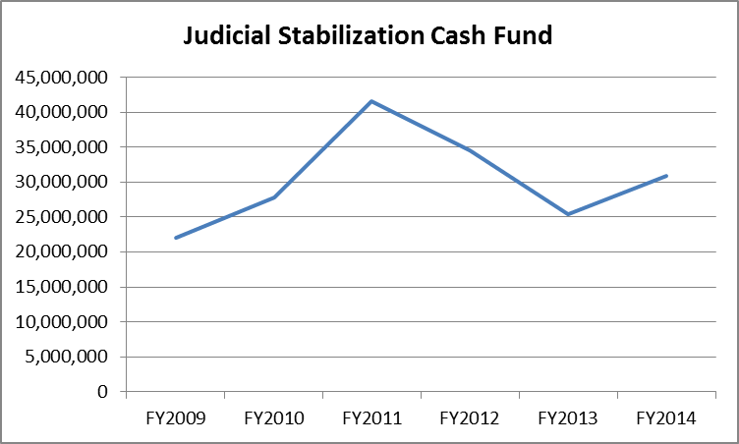

In addition, as more Counties move to the Model Traffic Code, thereby diverting traffic cases from State Courts, Cash Funds whose primary source of revenue is traffic cases have been in decline for several years:

**Traffic Based Case Funds**

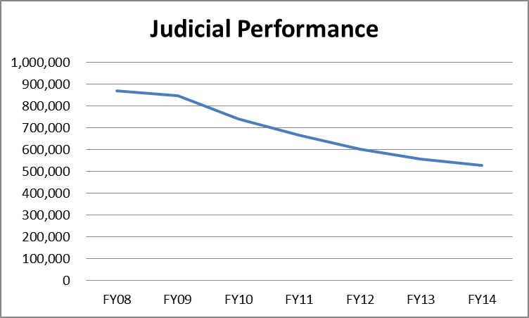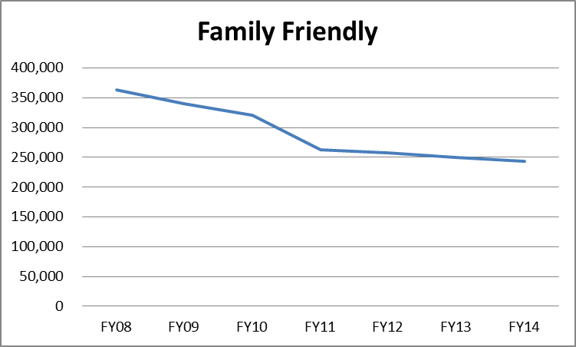

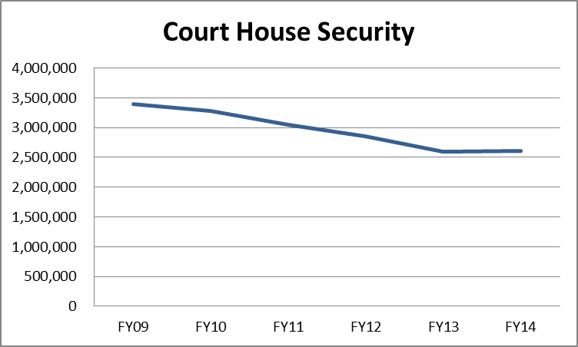

***Population growth***

Since 1990, the Colorado population has increased by 59 percent--an additional 1.9 million people. Colorado’s population is anticipated to grow by approximately 76,000 people in 2013 alone—that is the equivalent of adding a city the size of Longmont to Colorado annually. Colorado’s estimated growth rate in 2012, 2.2 percent, continues to outpace the U.S. average expected growth rate of 0.9 percent per year.Rapid population growth often places pressure on civic institutions, and Colorado’s courts are not immune from this pressure.

***Changes in demographics***

This dramatic growth in overall population has been accompanied by noticeable changes in the state’s demographics. These include: a continued aging of the state’s population, a sharp rise in the number of foreign-born citizens residing in the state, and an increase in not only the number of citizens speaking foreign languages but in the diversity of languages spoken as well. These demographic changes have a variety of impacts on the operations of Colorado’s courts and probation.

*Aging population*

Colorado has seen significant changes in the age of its population over the last decade. The number of Coloradoans over 45 years of age has increased faster than the population as a whole, growing by 121 percent from 1990 to 2013. Those over 45 years of age accounted for 28 percent of the state population in 1990, and are projected to rise to 40 percent in 2020 (see Figure below).

Nationally, approximately 13 percent of the U.S. population was over age 65 in 2010. With increased life expectancy and the aging of the baby boom generation in America, this segment is projected to account for 20 percent of the total population by the year 2030. As the population ages, the courts expect to see increases in case types such as probate and protective proceedings (i.e. guardianships and conservatorships). Unlike some types of court cases which can be resolved in a year or less, many protective proceedings cases require long term oversight by the courts.

Based on historical information, of the 2,500 protective proceedings cases filed annually, we would anticipate that:

* Half of the cases will require court monitoring for more than 5 years;
* A third of the cases will require court monitoring longer than 10 years;
* 15 percent will require court monitoring longer than 20 years; and
* 5 percent will still require court monitoring after 30 years.

After a period when new probate case filings were relatively stable, probate filings have sharply increased in the last few years. New probate case filings, protective proceedings and decedent’s estates combined, are up 22 percent just since FY 2009.

*Foreign languages*

Colorado’s foreign-born population more than doubled since 1990. By 2011, approximately 500,000 or 10 percent of the state’s population was foreign-born.[1] Compare this percentage to 1990 when only 4.3 percent of Colorado’s population was foreign-born. Much of this increase is due to Hispanic and Asian immigration.

According to the census data, the number of people in Colorado with limited English proficiency (LEP) has grown dramatically over the last twenty years—up 26 percent since 2000 and up 88 percent since 1990. The percentage of Colorado’s population speaking Spanish as the primary language at home increased from 6.7 percent in 1990 to 10.5 percent in 2000 to 12.1 percent in 2008. These figures are consistent with the increase in the state’s Hispanic population, as reported in the decennial census, which indicates that the percentage of residents identifying themselves as Hispanic grew from 12.9 percent in 1990 to 20.7 percent in 2010.[2]

Language and cultural barriers can create other obstacles such as misconceptions about the role of the court system and law enforcement. These challenges can create significant barriers for LEP litigants that can keep them from participating fully in their own court proceedings. In addition, they can result in the misinterpretation of witness statements to judges or juries during court proceedings and can deter minority litigants from using the civil justice system as a forum to address grievances. These concerns coupled with the growth in the LEP population amplify the significance of court interpretation as a management issue for the trial courts, which are increasingly compelled to use language interpreters in court proceedings. This growth in need is illustrated by the FY 2015 budget request for additional resources related to language interpreters.

The need for interpretive services adds another set of variables in the case management efforts of the state’s trial courts. Additional time is required to determine the need for interpreter services, to schedule the appearance of interpreters, to conduct proceedings using interpreter services, and to process payments for interpretive services. Further, if an interpreter is not available or does not show up to a hearing, proceedings must be delayed. These factors can add significantly to the time required to resolve cases.

***Increased reliance on technology***

As caseloads increase, the Branch has become increasingly reliant on technology to process the large volume of paper associated with trial court and probation cases.  The Colorado Judicial Branch has become dependent on its court/probation/financial case management system (i.e. ICON/Eclipse/JPOD) which integrates with applications from other agencies and departments.  The system has been a critical mechanism in maintaining service levels to the public while reducing the need for additional Branch resources.

The Branch developed an in-house Public Access system (PAS) that went live on July 1, 2010. Revenue raised from fees charged for public access to court data is now exclusively funding the PAS. In addition, the fees charged for public access helped fund the development of the new in-house e-filing system (Integrated Colorado Courts E-Filing System, ICCES). Development of ICCES began in FY 2011, and the implementation of the e-filing service in all judicial districts (phase I of the project) was completed on June 3, 2013. The ability for citizens to e-file court documents improves their access to the court system and helps make the courts more efficient.  To this end, the Branch has requested additional funding to improve network bandwidth in rural areas and provide information technology support to areas that lack those resources.

***Management Strategies and Measurements***

***APPELLATE COURTS***

**Colorado Supreme Court and the Colorado Court of Appeals**

Like every other court in the state system, the appellate courts in Colorado face the challenge of providing superior service with limited resources. It is through the efforts of hard-working and dedicated employees that the appellate courts have been able to maintain a high level of service. The retirement of the previous Clerk of the Supreme Court provided an opportunity to maximize operational efficiency by utilizing a single Clerk of Court to administer both appellate courts. This administrative change has also allowed the two appellate courts to better integrate workflow and allow for cross training opportunities. It is anticipated that combining appellate administration will allow support staff to take better advantage of economies of scale presented by the combined staff.

***TRIAL COURTS***

**New Case Filings**

While total trial court filings have declined in the last year, the decrease has not been uniform. Some significant case types have increased over the past year, including criminal, mental health, and probate cases. In addition, the last decade has seen a considerable increase in case types that are most directly influenced by economic pressures, such as district court civil cases that include foreclosures and tax liens (see figures below).

**County Court Filings by Case Type**

(Does not include Denver County Court)



1. Felony complaints represent the number of criminal cases, docketed as (CR), that begin in county court. The processing of felony cases varies between locations. The counties processing CR cases hear advisements. Some counties do preliminary hearings in county court before moving the case to district court for completion of the felony process. The case can also be reduced to a misdemeanor and remain in county court. The cases retain the same docket number in either county or district court. (b) Does not include felony complaints.

**District Court Filings by Case Type**

***Trial Court Management Strategies***

In managing its limited resources, the Branch has focused on making the courts accessible to the public, ensuring that cases are resolved in a timely manner, and assisting individuals with navigating the court system. To achieve these goals, the Branch in recent years has requested and received resources related to public access and the efficient and effective operation of the court system. These resources include: (1) language interpreters who help individuals who do not speak English as their primary language access the courts and understand the court process; (2) family court facilitators to improve the public’s access to Domestic Relations court proceedings, expedite the processing of cases involving the dissolution of marriage and parental responsibility disputes, and provide early, active, and ongoing case management; and (3) self-represented litigant coordinators who provide self-represented litigants with the information they need to proceed with their cases, thereby increasing citizen access to justice and allowing for more streamlined case processing.

Performance goals for trial courts have been established through various means, including Chief Justice Directive 08-05 (Case Management Standards). This directive was developed with input from judges and establishes aspirational time processing goals for each case class. Information about each district’s progress in meeting the goals is reported quarterly. Information for individual judges is provided to the Judicial Performance Commission during each judge’s retention evaluation. The following tables reflect the time standards for district and county courts:

|  |  |  |  |
| --- | --- | --- | --- |
| **TABLE 1** | | | |
| **District Court Case Management Time Standards** | | | |
| **Established Pursuant CJD 08-05** | | | |
| **Case Class** | **Pending Cases Exceeding Target** | | **Target** |
| **1st Quarter FY 2013** | **3rd Quarter FY 2014** |
| Civil | 16.8% | 13.9% | No more than 10% of cases open more than one year. |
| Criminal | 6.6% | 4.9% | No more than 5% of cases open more than one year. |
| Domestic Relations | 5.4% | 3.3% | No more than 5% of cases open more than one year. |
| Juvenile Delinquency | 4.7% | 1.1% | No more than 5% of cases open more than one year. |
| Dependency and Neglect (over 6 years old)* | 6.7% | 5.3% | No more than 5% of cases open more than 18 months |
| Dependency and Neglect (under 6 years old)* | 9.4% | 7.7% | No more than 10% of cases open more than one year. |
| Due to data conversion from BRIO to COGNOS, FY13 results are not available for 2nd thru 4th quarters.  * The standards in dependency and neglect are under review. This measure shows time to first permanency hearing. | | | |
| A more optimal measure would be time to true permanent placement or termination of court jurisdiction. | | | |

|  |  |  |  |
| --- | --- | --- | --- |
| **TABLE 2** | | | |
| **County Court Case Management Time Standards** | | | |
| **Established Pursuant CJD 08-05** | | | |
| **Case Class** | **Pending Cases Exceeding Target** | | **Target** |
| **1st Quarter**  **FY 2013** | **3rd Quarter**  **FY 2014** |
| Civil | 6.4% | 5.1% | No more than 5% of cases open more than six months. |
| Misdemeanor | 13.6% | 13.0% | No more than 10% of cases open more than six months. |
| Small Claims | 6.4% | 4.1% | No more than 1% of cases open more than six months. |
| Traffic | 6.8% | 5.2% | No more than 5% of cases open more than six months. |
| DUI/DWAI | 14.4% | 14.0% | No more than 20% of cases open more than seven months. |
| Due to data conversion from BRIO to COGNOS, FY13 results are not available for 2nd thru 4th quarters. | | | |

***PROBATION SERVICES***

In the last ten years, Probation has experienced a number of changes. There has been significant growth in the number of adults sentenced annually to Probation: from 25,720 in FY 2004 to 49,767 in FY 2013. The number of individuals on active supervision on June 30 of each year has increased from 47,076 in 2004 to 80,807 in 2013. During that same period, there has been a steady decline in the number of juveniles sentenced annually to probation: 6,823 to 4,540. There has also been a shift in the number of felony versus misdemeanor convictions and sentences to probation. In FY 2004 the percentage of new cases sentenced for a felony offense was 72 percent; in FY 2013 it was 44 percent. Much of this change is the result of statutory changes, particularly in the area of drug crimes and alcohol related driving offenses. Other changes include increases in the percentage of female defendants and a decrease in the percentage of the probation sentences for individuals between the ages of 18-24 and a corresponding increase for those between the ages of 25- 40+.

Over this ten year period of time, Probation has continued to work to identify and utilize assessments, processes and programs that uphold public safety, are cost effective, and increase positive outcomes. In the last few years there has been a focus on the identification and implementation of evidence-based practices (EBP) and principals. To be considered an EBP a program or practice has undergone significant research rigor and if implemented correctly will deliver improved outcomes. This effort is consistent with the principles of procedural fairness and evidence-based decision making as the concept of EBP supports the approach of working with each individual on the basis of their unique needs. To better meet this objective Probation was appropriated 3.0 FTE for the Division of Probation Services to further the implementation of evidence-based practices throughout the state.

Probation is currently authorized staffing at 90.4 percent of need. Through quality assurance practices, performance feedback, and coaching, probation supervisors play a vital role in the effective implementation of evidence-based principles and practices. Tending to the daily management of their units contributes to the overall management of the department, a fundamental need of every organization. For these reasons, Probation’s five year plan is to increase staffing levels of supervisors to 100 percent while maintaining current levels for probation officers and support staff. As illustrated in the tables below, the total FTE need over 4 years is 86 staff (32 supervisors, 44 probation officers and 10 support staff).

|  |  |  |  |  |  |  |  |
| --- | --- | --- | --- | --- | --- | --- | --- |
| **Requested Allocations (in FTE)** | | | | | | | |
|  | **FY 2014** | **FY 2015** | **FY 2016** | **FY 2017** | **FY 2018** | **FY19** | **FY 2015-19** |
| Regular PO's (sup & PSI; adult & juvenile) | 0.0 | 0.0 | 0.0 | 24.0 | 10.0 | 10.0 | 44.0 |
| Intensive PO's (adult & juv) | 0.0 | 0.0 | 0.0 | 0.0 | 0.0 | 0.0 | 0.0 |
| Support Staff | 0.0 | 0.0 | 0.0 | 6.0 | 2.0 | 2.0 | 10.0 |
| Supervisor | 0.0 | 0.0 | 10.0 | 10.0 | 7.0 | 6.0 | 33.0 |
| **Total Appropriated FTE** | **0.0** | **0.0** | **10.0** | **40.0** | **19.0** | **18.0** | **87.0** |

|  |  |  |  |  |  |  |
| --- | --- | --- | --- | --- | --- | --- |
| **Percent Staffed** | | | | | | |
|  | **FY 2008** | **FY 2009** | **FY 2010** | **FY 2011** | **FY 2012** | **FY 2013** |
| PO's (Adult & Juv, PSI's, Regular State & Private Sup) - No intensive in FY08 only | 95.4% | 94.4% | 93.4% | 95.0% | 95.0% | 95.0% |
| Support Staff | 75.0% | 74.3% | 73.5% | 75.3% | 75.3% | 75.3% |
| Supervisors | 82.6% | 81.7% | 87.9% | 93.9% | 97.6% | 100.6% |
| **Overall** | **90.4%** | **89.4%** | **89.3%** | **91.4%** | **91.8%** | **92.1%** |

In FY 2008, the Chief Probation Officers agreed to establish target success rates for the three probation populations with the lowest success rates. In FY2009, Chief Probation Officers elected to establish target success rates for all of the probation populations. At that time, all district probation departments received quarterly reports on their progress toward the established goals. In addition, Probation offered technical assistance and additional training to the district departments to assist them in developing plans to improve their outcomes. The result was that at least three programs met their target every year through FY 2012. In FY 2013, several programs maintained previous year’s success rates but fell short of aggressive targets. These results, measured in percentages and actual numbers of cases, are below. The programs that met or exceeded target success rates are in bold.

|  |  |  |  |  |  |  |
| --- | --- | --- | --- | --- | --- | --- |
| **Program** | **FY 2009 Actual** | **FY 2010 Actual** | **FY 2011 Actual** | **FY 2012 Actual** | **FY 2013**  **Target** | **FY 2013**  **Actual** |
| Regular Adult | **64%** (10,629) | **66%** (11,678) | **68%** (12,407) | **67%** (13,325) | 70% | 66%  (14,151) |
| Adult ISP* | **66%**  (810) | **66%** (809) | 67% (700) | 64% (731) | 68% | 61%  (673) |
| Female Offender Program* | 73% (147) | 69% (99) | 70% (112) | 67% (104) | 72% | 66%  (101) |
| Sex Offender ISP* | 46% (124) | 39% (138) | **46%** (135) | **45%** (149) | 42% | **45%**  (176) |
| Regular Juvenile | 74% (3,485) | 73% (3,285) | **74%** (2,940) | **75%** (2,855) | 76% | 72%  (2,517) |
| Juvenile ISP* | **45%** (245) | **46%** (271) | **50%** (223) | **50%** (199) | 50% | 45%  (144) |

*Due to the smaller number of probationers in some intensive programs, the actual success rate may experience drastic fluctuations.

***Probation Management Strategies***

To maintain and improve current levels of success Probation continues to pursue the goal of full staffing and to aggressively work to implement applicable evidence-based practices and programs, training and skill testing. Probation’s current efforts to improve outcomes include the following:

* Evaluate the implementation of the Colorado Juvenile Risk Assessment (CJRA) instrument. The CJRA was fully implemented in February 2013 and the coming years will focus on evaluating the effectiveness of the instrument. This is an improvement in the area of juvenile assessment, as the CJRA identifies strengths as well as risks and provides better information from which to develop case plans and provide more targeted supervision.
* An on-going review of the adult and juvenile screening and risk/need assessment instruments with planned upgrades. The juvenile sex offender assessment instrument was replaced by the research-based Juvenile Sex Offender Assessment Protocol (JSOAP) in September 2013. The adult sex offender assessment instruments will be updated in FY 2014 and FY 2015, through a grant from the federal government. This is in support of the Judicial Branch’s broader support for evidence-based sentencing.
* A format has been developed for the reporting of risk/need information to the courts prior to sentencing. This effort comes in support of the Chief Justice’s Evidence-Based Decision Making initiative. The Assessment Summary report is currently available for districts to use in adult sentencing courts.
* Case planning practices are currently under review. This effort is in support of the other evidence-based practice improvements currently underway, as the case plan is the repository for much of the information generated by assessment. A new standardized-format that better integrates assessment results and criminogenic needs specific to individual probationers has been developed.
* A study of Colorado’s cognitive-behavioral skill building classes and the primary curriculum (Thinking for a Change – T4C) was completed resulting in a number of recommendations to strengthen the curriculum, training, and support for probation-based facilitators. Newly approved lesson plans have been added to the curriculum and a quality assurance checklist has been developed. Methods to improve client referral processes and retention rates are underway and strategies, such as communities of practice, are being developed to provide more support and performance feedback to T4C facilitators.
* Changes in the law have led to the retirement of the Adult Intensive Supervision Probation (AISP) Program, and the development of a replacement program. The new program, LS-Intensive Probation is the most intensive level of probation supervision, which was designed specifically for the higher risk/lower needs population. Implemented in the fall of 2013, an evaluation is being designed to review the effectiveness of the new program’s components.
* The development of offender typologies and evidence-based supervision strategies was initiated for the adult probation population. The remaining six typologies will be further defined and appropriate programming identified for these unique populations.
* Development of a structured decision-making process for responding to violation behaviors and reinforcing positive behaviors with the goals of harm reduction, improved success and long-term behavioral change. Known as Strategies for Behavior Change (SBC), this process has been pilot tested and automation of it is nearly complete. Statewide implementation will follow the pilot test of the automation and implementation process.
* Participation with four other agencies in a $2.1M multi-agency training Justice Assistance Grant awarded to the Colorado Department of Public Safety in October of 2009 has ended. With the passage of HB 13-1129, the capacity to support the core foci of the grant has been retained in the form of the Evidence- Based Practices Implementation for Capacity (EPIC) resource center. Probation continues its engagement with EPIC to implement motivation interviewing skill training in Probation.
* In addition to the required training delivered statewide by the Training Unit in the Division of Probation Services, skill training is being delivered for the new evidence-supported programs and practices mentioned throughout this section. Included is coaching training for supervisor’s to increase support for the use of new practices and to support continuous quality improvement.
* Juvenile probation strives to expand the use of Family Functional Therapy and Multi-Systemic Therapy for juveniles; both are evidence-based programs, as well as cognitive behavioral programs.
* Monthly publication and distribution of *Research in Brief* to all probation departments. Relevant criminal justice research is reviewed and summarized on a single page with a focus on providing enhanced understanding of current research and practical tips for application in probation. This publication has achieved a national following.
* Expansion of performance feedback efforts including quarterly statistical reports summarizing progress toward reaching targeted outcomes for all probation programs/populations, the statewide results of which are in the table above.
* Continuation of the Rural Initiative program to facilitate the training and state approval of domestic violence, sex offender and substance abuse treatment providers in rural counties. This effort is intended to provide quality treatment “close to home” for probationers who would otherwise be required to travel significant distances to secure treatment. This project has reduced technical violations and improved treatment compliance. The initiative is supported by offender pay cash funds.
* Utilization of a variety of mechanisms to monitor low-risk probationers in a cost effective manner that creates increased time to be devoted to the management of higher risk offenders’ supervision without the loss of accountability for a large segment of low risk probation population. Examples include telephone reporting for low risk clients and daily reporting requirements for the highest risk populations and the development of large low-risk only caseloads and smaller higher-risk only caseloads.
* A workload value study has been initiated to determine the amount of time needed for officers to more fully implement evidence-based principles and practices. The work of probation supervisors, the linchpins to EBPs, will also be studied to develop an adequate ratio of supervisors to staff. Importantly, a ratio of support staff to probation staff will be reviewed and determined. Individuals in all three job categories play an important role in the efficient and effective implementation of evidence-based practices.

1. Source: U.S. Census Bureau, 2008 American Community Survey, C05002, "Place of Birth by Citizenship Status" and C05005, "Year of Entry by Citizenship Status," accessed October 2009.
2. The census data indicates that there has also been growth, although not as large, in persons speaking Asian and other non-English languages.