Colorado Problem Solving Court Team Member Mentor Application
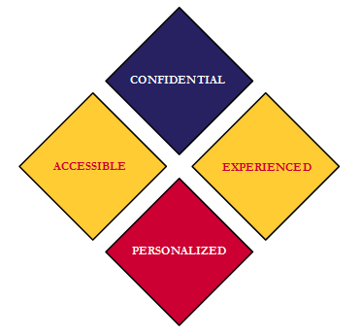
First Name:
Last Name:
E-Mail:
Phone:

Current Role/Discipline:
Prior Role(s)/Discipline(s):

Preferred Mentor Role:

Employment History (in your current profession):

Place of Employment | Job Title | Dates of Employment

- Please describe your specific experiences working in a problem solving court:

- Why are you interested in becoming a mentor to a colleague that is new to working in a problem solving court setting?

- Please describe what training you have received in evidence based practices and other related topics relevant to working in a problem solving court:

- Have you been asked to provide any training and/or present on the topic of problem solving courts? If so, please describe:

- Please describe in your own words, what your profession’s role should be as it pertains to participation in a problem solving court:

- How would you describe your communication style (i.e. phone, email, in-person, text)?

- What is the approximate amount of hours you would have available to mentor each month in the upcoming year?

- Have you had any experience being a mentor either informally or formally in your current position or any other capacity?

- Is there anything else you would like for us to know?

- Please provide two references from your problem solving team outside of your discipline and provide their contact information.

Reference #1:
Relation:
Contact Info:

Reference #2:
Relation:
Contact Info:

- FOR LICENSED COLORADO LAWYERS SEEKING CLE CREDIT THROUGH THE COLORADO ATTORNEY MENTORING PROGRAM (CAMP):

Attorney Registration#: ___________________________________________________________________

Other jurisdictions where you are licensed (provide date of licensure): ______________________________
____________________________________________________________________________________________

Total Years in Practice: _________

Have you been suspended or disbarred from the practice of law in any jurisdiction, or have you surrendered your license to practice law for the purpose of disposing of a pending disciplinary proceeding in any jurisdiction?

______Yes _____No

Have you been sanctioned by a governing authority in the five years preceding application as a Mentor? (“Sanctioned by a governing authority” includes receiving any form of discipline, public or private, from an attorney regulatory or licensing authority, being held in contempt of court for conduct in connection with a legal proceeding, or being fined or monetarily sanctioned by a court for rule violations or conduct before the court or within the scope of a legal proceeding.)

______Yes _____No

*** APPLICATION CONTINUES ON THE NEXT PAGE ***
Do you authorize the Colorado Supreme Court Office of Attorney Regulation Counsel to disclose to the Executive Director of the Colorado Attorney Mentoring Program the existence of private discipline imposed on you during the five years immediately preceding the date of your signature on this application?

______Yes _____No

_________________________________ ________________________________
Signature Date

PLEASE SEND THE COMPLETED FORM BY EMAIL TO:

Sarah.keck@judicial.state.co.us

