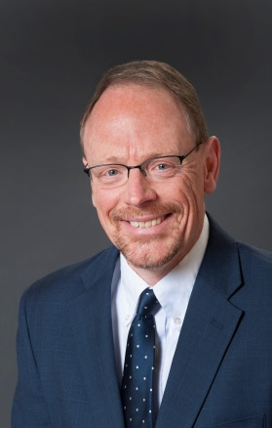 Mike J. Maday
Michael J. Maday is a provider of mediation and training services to businesses, schools, families and the courts. Mike has 35 years’ experience as a social worker with children and families. He has mediated since 1984 in Colorado Springs, where he specializes in family and civil mediation. He has mediated court ordered family, child protection and civil cases under contract with the Colorado Office of Dispute Resolution since he helped establish that program in Colorado Springs in cooperation with the courts in 1987. He has also mediated special education disputes and Workers Compensation cases. He has experience developing and implementing school based conflict resolution programs that emphasize student mediation as a way to resolve conflicts.
Mike has trained over four thousand people in negotiation, mediation and violence prevention skills including attorneys, mediators, business people, mental health professionals, teachers, parents and students from throughout North America. He has taught mediation at the University of Denver’s Graduate School of Social Work.
Mike received a Master of Social Work Degree from the University of Denver. He is a Practitioner Member of Family Section of the Association for Conflict Resolution and a member of the Board of Directors of the Mediation association of Colorado. He was recently appointed to the Colorado Judicial Performance Commission.

