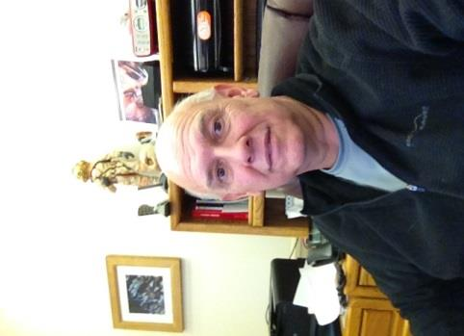
Kent Gray, Mediator Profile

The son of a police officer, Kent Gray majored in Criminal Justice in his undergraduate program. Kent has the distinction of being one of the few people who will admit they were inspired to pursue the law by Geraldo Rivera, who at that time was a Legal Aid and Defender’s attorney in NYC!.
While in law school, Kent participated in Legal Aid, representing a number of indigent people accused of crimes, and even had two Jury trials before graduating from law school. After that he was hooked, and wanted to be a trial lawyer. He also felt a special affinity to the defense side of things, as he enjoyed fighting for the underdog.
Kent graduated from CU Law School in 1982, where he took classes on mediation, arbitration and collective bargaining. He became a Public Defender in October, 1982 in the Colorado Springs office, was the Head of the La Junta Regional Public Defender's Office from July, 1988-July 1, 1989, and then returned to the Colorado Springs Office and remained there until he went into private practice January of 1997.
He was drawn to mediation by a desire to see if victim/offender and other restorative justice type programs could be promoted. This is an area of ADR in which he would like to see ODR play a bigger role. Kent was trained in mediation at CDR in Boulder in December, 2001, and began mediating with ODR in February of 2002. He does mediations privately and also works as a Special Master on Domestic Law cases.
Kent continues to practice as a defense attorney. He says the best part of defense work is helping to ensure a fair result for people who aren’t used to getting fair treatment. The worst part of the job is feeling that a “just” result was not reached, as the system is stacked against a poor defendant. The best aspect of mediation, Kent says, is helping the parties reach an amicable settlement, without having to go through the time and expense of going to court. The worst part of mediation is wondering if he could have done something differently when parties don’t resolve their case.
Kent came to Colorado from Wisconsin as a kid on family vacations, and as an adult realized that he could live here and be on permanent vacation! As a skier and tennis player, Colorado was a natural choice. As a scuba diver instructor, Colorado seems a less natural choice. While this has often been pointed out to Kent, like any good mediator, he continues to insist that it’s negotiable. Based on the frequency of his trips to Mexico, however, the rest of us suspect he has re-evaluated his BATNA!**
**For those who haven’t done mediation training: BATNA means Best Alternative to a Negotiated Agreement, otherwise known as how bad will it be if I’m wrong??!!

