John G. Otto
Attorney at Law
305 Main Street, Suite B
Colorado Springs, CO 80911
719-390-7811
Johnotto @ msn.com

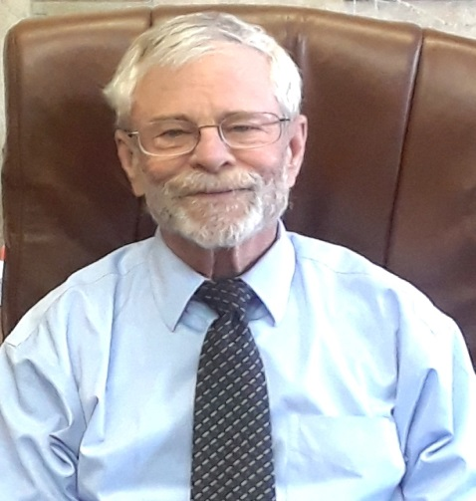

Re: Resume of John G. Otto

John G. Otto received his law degree from the University of Denver Law School in 1973; and his B.S. from the University of Colorado in 1969. He is a member of the American Academy of Matrimonial Lawyers (1995 to 2015), and has served in numerous capacities with the El Paso County Bar Association. He limits his practice to all fields of domestic law including litigation, mediation, arbitration, court appointed Master, and collaborative law. He is an A.A.A. Arbiter; and admitted to practice in front of the United States Supreme Court. He has been recognized in numerous legal publications including: the Legal National Registry of Who’s Who; The Best Lawyers in America, Colorado 5280 Superlawyer; the Metropolitan Who’s Who in Law Honors Edition; and has a Distinguished Peer Review Rating from Martindale-Hubbell. He has been an adjunct Professor of law; and did regularly lectures on domestic law issues, including an annual update of Colorado family law and other topics. He has been licensed and trained in Collaborative law conflict resolution protocols, including: Level I and level II, and completed his Basic Training as a Mediator He has been appointed or privately retained as a Master, Mediator, and Arbiter in numerous complex family law cases; been endorsed and accepted as an expert in attorney fee litigation cases, legal malpractice issues; and common law marriage issues. He has participated in 30 or more appeals in the Colorado Supreme Court and Court of Appeals.

John G. Otto

