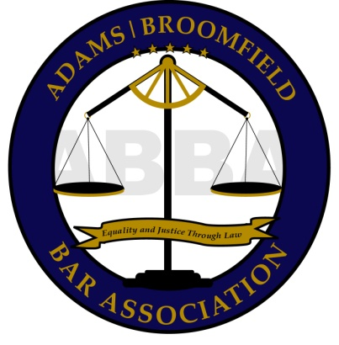

PRO SE DIVORCE CLINIC

Presented by ABBA and the 17th JD Access to Justice Committee

This is a free divorce clinic for persons seeking to obtain an uncontested divorce. Attorney volunteers will provide an overview of divorce law and procedure in Colorado. You can also ask questions on how to fill out and file your own paperwork.

Please obtain the forms for Dissolution of Marriage or Legal Separation prior to attending the clinic. These forms can be purchased at the Clerk’s Office on the First Floor of the JusticeCenter or downloaded free of charge at www.courts.state.co.us “Self Help Center”.

Advance registration is not required, and there are no income eligibility requirements. The clinic will begin promptly at 4:30 p.m. Please contact Ingrid Burns with questions at (303) 451-0300 or email to ingridburns@colo-law.com.

2014 SCHEDULE

LOCATION: January 23rd
February 27th
Adams County Justice Center March 27th
Training Room, 1st floor April 24th
1100 Judicial Center Drive May 22nd
Brighton, CO80601 June 26th
4:30 p.m. July 24th
August 28th
September 25th
October 23rd
November 20th
December– NO CLINIC

This clinic is a public service of the Adams/Broomfield Bar Association, the 17th JD Access to Justice Committee, Ciancio Ciancio Brown, P.C. and various other private volunteer attorneys. The clinic is for educational purposes only and should not be considered a substitute for hiring an attorney.

