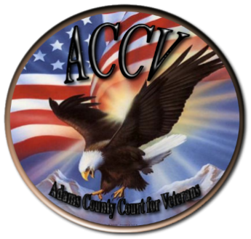
Adams County Court for Veterans
Mentoring Program Information Sheet

Mission Statement
The Adams County Court for Veterans Mentor Program pledges to ensure no veteran is left behind by guiding veterans through the criminal justice process, connecting them to available resources, supporting the veteran during their readjustment to civilian life, and becoming an ally.

Vision Statement
The vision of the Veteran’s Mentoring Program is that No Veteran is Left Behind.
Having veterans participate as mentors is an important part of the Adams County Court for Veterans as there is a bond that occurs between veterans around the values that are shared and the sacrifices that have been made.
The Mentoring Program offers support and encouragement for veterans in the court system by spending one-on-one time with the veteran after they appear in front of the Veterans Court. These mentoring sessions usually do not last longer than ten minutes and give the veteran the opportunity to bring up concerns and get feedback and support from another veteran. The Mentor has a Resource Book at his/her disposal to refer veterans to a wide range of available services. These include Medicaid (for vet’s family), Food Stamps, Civil Service Agencies, employment, housing, legal, etc. The mentor is a resource to the veteran, NOT A COUNSELOR.
Trainings on how to lead a mentoring session, what to ask, how to ask, and how to listen to answers, are offered as part of the orientation trainings.
The Adams County Court for Veterans Mentoring Program also offers support and supervision to all of the mentors from the Team Leaders and the Mentor Coordinator as well as from the other mentors in the program. Support is the main component of the program, for the veterans involved with the court system as well as the mentors in the program.
The Mentoring Program is looking for a six month commitment from all volunteer mentors in order to maintain the program at a level that will be effective in supporting the veterans in the court system. All potential mentors are required to fill out an application and complete a short face-to-face interview with the Mentor Coordinator and each Team Leader before being accepted into the program. Observational activities, including observing the court proceedings and observing other mentors, will be completed prior to a new mentor leading a mentoring session.

Contact Information
Darnelle O’Hair – Veterans Court Mentor Coordinator
303-654-3298

