14th Judicial District Self-Help
Grand, Moffat & Routt Counties
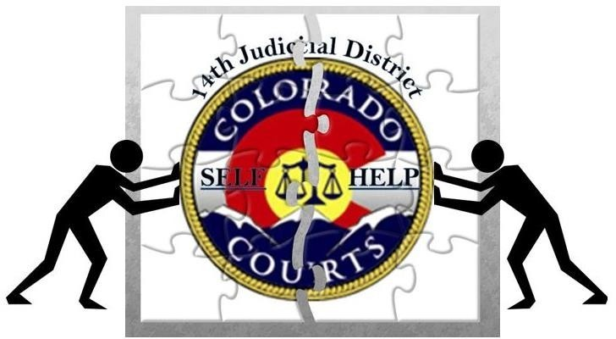

To make an appointment with a Sherlock (Self-Help Litigant Coordinator), contact:

Grand | Moffat | Routt
307 Moffat Avenue | 1198 W. Victory Way | 1955 Shield Drive
Hot Sulphur Springs | Craig | Steamboat Springs
970-725-3357 ext. 7 | 970-824-8254 ext. 7 | 970-879-5020 ext. 7
You are welcome to send an email to the Self-Help Inbox at 14SelfHelp@judicial.state.co.us

For an existing appointment, you may click the name of the Self-Help Litigant Coordinator you are meeting with
to join the meeting virtually via webex at your scheduled appointment time.

JOIN MEETING WITH LINDA MANGUSO or call 720-650-7664, meeting # 2591 679 6541#
JOIN MEETING WITH EVGENEIA DOLOS or call 720-650-7664, meeting # 2591 679 6541#

Self Help Personnel Cannot provide legal advice or answer questions about Traffic tickets or Criminal cases and cannot assist Attorneys.
For more information refer to Notice To Self-Represented Litigants – CJD 13-01.

Search All Court Forms

FORMS AND INSTRUCTIONS
MONEY CASES | MISCELLANEOUS | FAMILY CASES
Small Claims under $7500 | Motion to Waive Filing Fee | Allocation of Parental Responsibilities
County Civil under $25000 | General Motion | Divorce/Separation w/ Children
County Civil-Answer | General Order | Divorce/Separation w/o Children
District Civil Cover Sheet | General Response | Modify or Restrict Parenting Time
Civil Contempt | Family Case General Motion | Modify Child Support
Set Aside Default Judgment | Family Case: General Order | Enforce a Court Order
Civil Glossary of Terms | Respond to a Motion-Family | Unable to Locate other Party to Serve
 | Flexible Caption | Completing an Income Assignment
EVICTIONS (FED) | Issuing a Subpoena | Maintenance Worksheet - Manual
Forcible Entry and Detainer | Transcript Request Form | Parenting Time Disputes
 | Notice of Change of Address | Register a Foreign Decree
APPEALS |  | Case Information Sheet 4 Parties
COA Forms and Policies | RECOVERING PROPERTY
Small Claims and County Court | Replevin | PROBATE
Request a Magistrate Review |  | Probate with a Will
 | SEAL MY CASE | Probate without a Will
JUDGMENT COLLECTION | Expunge Juvenile Records | Guardianship/ Conservatorship
How to Collect a Judgment | Seal A Criminal Conviction | Guardian and Conservator Reports
Garnishment/Interrogatories | Seal a Non- Conviction
Types of Garnishments | Seal in re: §24-72-705 | PROTECTION ORDER
Register a Foreign Judgment  *Including Dept of Labor* | Seal a Municipal Court Case Conviction | Obtaining/Modifying  A Civil Protection Order

Forms by Case type/Category Forms by Form/JDF Number

Probate/Estate Process
Seal Records
Child Custody
Divorce
Money Cases

Petition for Custody
Domestic Case Information Sheet

Separation Agreement
Grandparent- Petition for Custody
Small Claims- Notice, Claim & Summons to Appear
Sworn Financial Statement

Parenting Plan
Petition for Dissolution of Marriage/Separation
SAMPLE FORMS
STEP BY STEP INSTRUCTIONS

