FREMONT COUNTY JURY TRIAL PLAN

- Overview

As of June 15, 2020, Fremont County has had 32 Covid-19 cases (twenty-five positive and 5 presumptive positive). According to the Canon City Daily Record, 25 of those cases have since recovered.

On May 20, 2020, Governor Jared Polis approved a variance for Fremont County from Executive Order D 20-044 Safer at Home and Public Health Order 20-28 Safer at Home. The variance allowed Fremont County to begin opening Restaurants, Fitness Facilities, Places of Worship, and Recreation and Outfitters, among other items, provided certain measures were in effect. The variance also noted the Fremont County new-case threshold of 25 new cases in a week would trigger rescinding of the variance. This threshold has not been met. Fremont County has had just 10 new positive cases since April 25, 2020. The Court would adopt this threshold in utilizing this exemption as well.

Judges and Court Staff in Fremont County met with Public Health officials on June 10, 2020. Also present were members of the Sheriff’s office, Public Defender’s Office, and District Attorney’s office. At that time, all parties were able to provide feedback to the proposed plan, and that feedback is incorporated into this request.

In addition, Fremont County will be conducting a trial-run of the jury check-in and Voir Dire process, utilizing members of court staff, on June 26, 2020. The final process will be adjusted in order to accommodate any issues that arise.

Fremont County seeks an exemption from the Chief Justice’s jury trial moratorium in order to conduct jury trials in Courtroom 101. One-day county court trials are scheduled every Thursday, and we would like to proceed with those as scheduled. Fremont would start with county court trials only, but we are including district court information as well in the event the district court judges wish to also adopt this plan. Should a district court judge move forward in July, their trial would be held in Courtroom 101 and would take priority over a county court trial. Only one trial would occur at a time, with no more than two trials in a week. See Exhibit A, July Trial Calendar.

Prior to any case proceeding to trial, a hearing will be held regarding logistics and procedure for the trial to move ahead safely and in accordance with this plan.

- Courtroom 101

All trials held pursuant to this exemption would be held in Courtroom 101, the only courtroom in this county of this design.
Courtroom 101 is a large courtroom with a seven-person jury box. The gallery can seat twenty-two people at a six-foot distance, and if the jury box were also utilized the room could fit twenty-four potential jurors. In addition, a CJA, the Judge, DA, Defense Attorney, defendant, and witness would all need to be present. This request will address members of the public in a later section.
The benches in the courtroom are already marked with tape X marks to indicate where individuals should sit in order to remain six feet away from any other person.

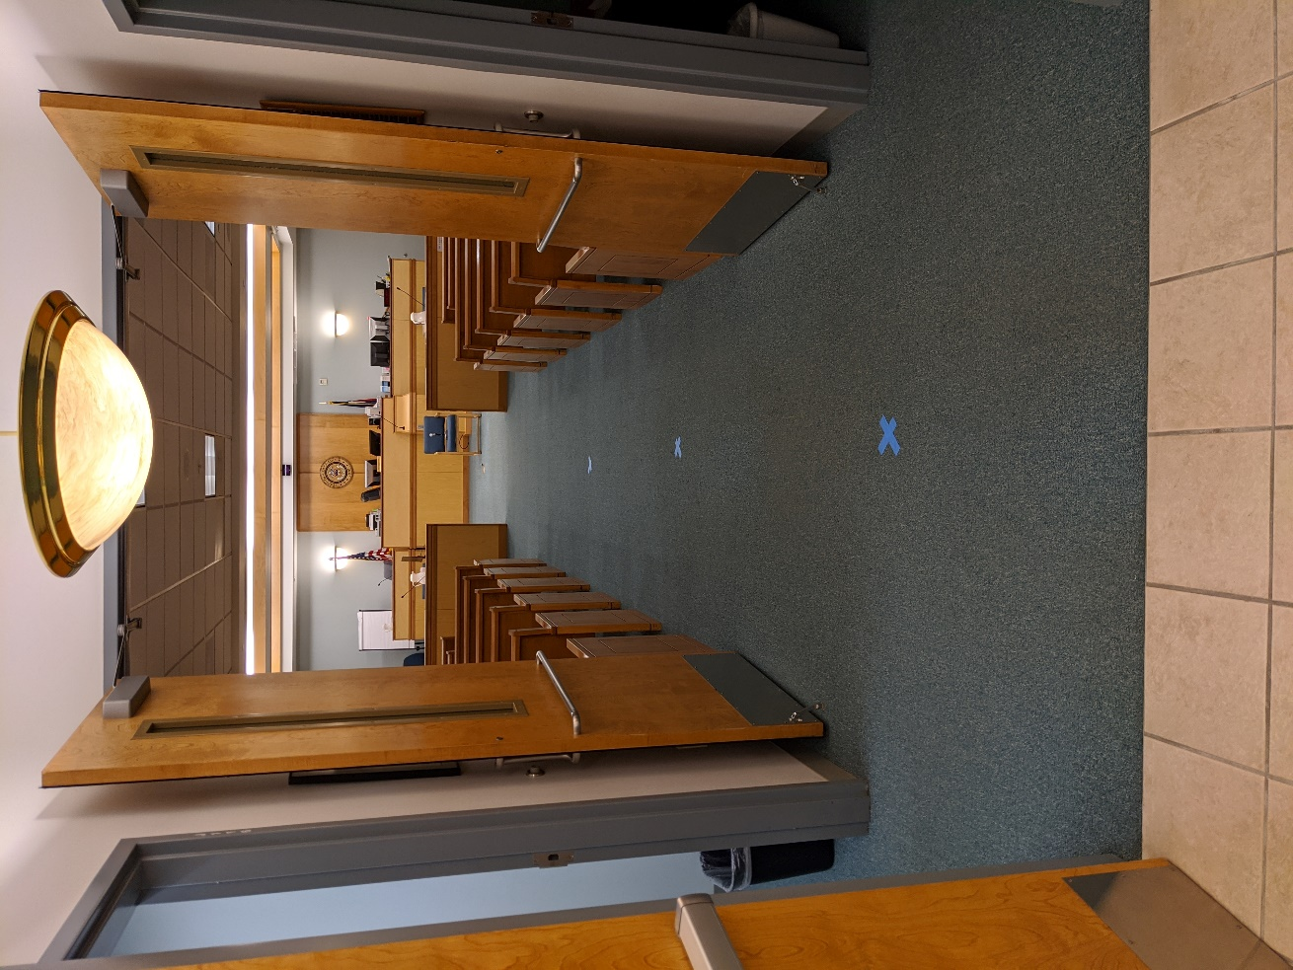

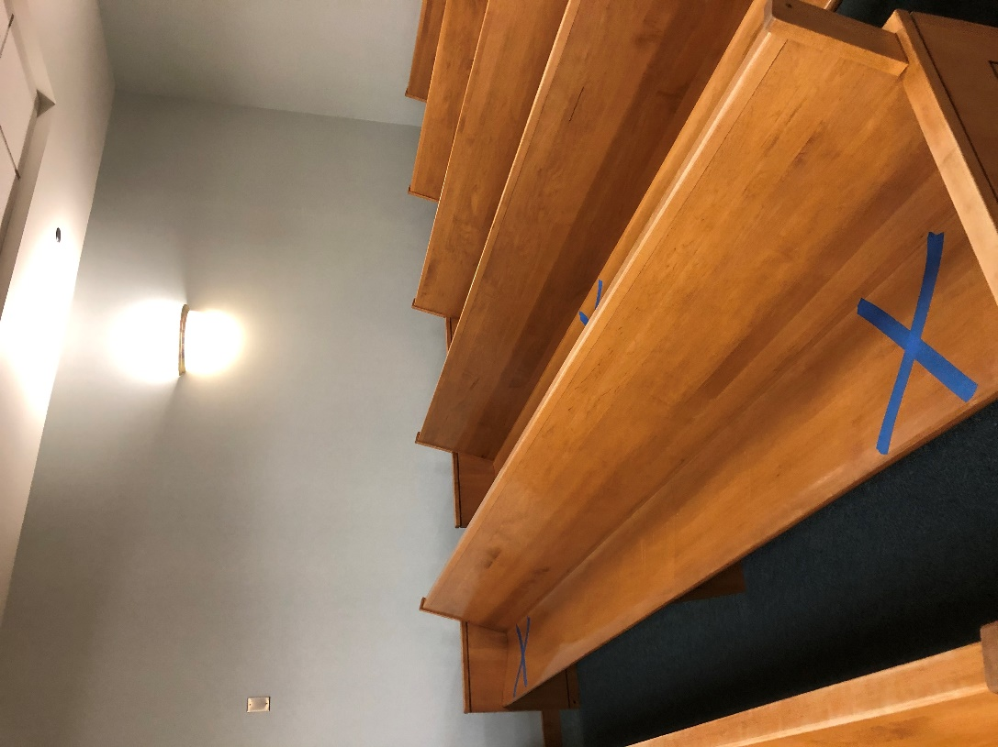

- Juror Summonses

Summonses were mailed out June 11, 2020, summoning citizens for jury duty on July 7, 2020, and July 9, 2020. This was done in order to ensure citizens received their summons with enough time to make arrangements, in the event this exemption is granted. They contained language in the summons stating: Fremont County Combined Court will be in compliance with the CURRENT COVID-19 distancing recommendations and jurors are encouraged to wear masks. If you do not have a mask one will be provided to you if you are required to report. Go to http://fremont.cojury.org for CURRENT information regarding you appearance or to request a postponement or disqualification of service.

The juror website currently states: The Court has implemented extensive cleaning and disinfecting practices during all phases of the jury process. If you or members of your household are in the population vulnerable to Covid-19 and wish to reschedule your jury service please complete a postponement request with a comment about Covid-19. If you have a cough or fever please call the jury commissioner to reschedule your jury summons date.

Jurors with COVID-19 concerns or issues will be permitted to contact the jury commissioner prior to the trial date to postpone jury service, even if they have already been given one postponement.

- Juror Arrival at Courthouse

The Jury Commissioner and her staff will have a station set up outside the entrance to Fremont courthouse to welcome those reporting for jury duty. Outside the courthouse, Xs will be marked at six-foot intervals for those waiting in line to maintain social distance. The Jury Commissioner, her deputies, or courtroom division staff will confirm that each juror has brought his/her filled-out standard statewide summons questionnaire.

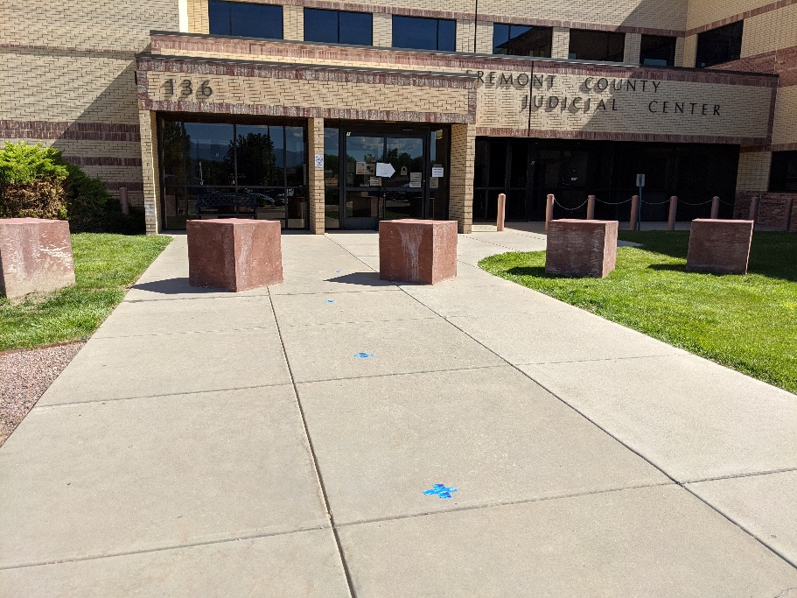

(Jury Commissioner tables and Questionnaire not pictured)
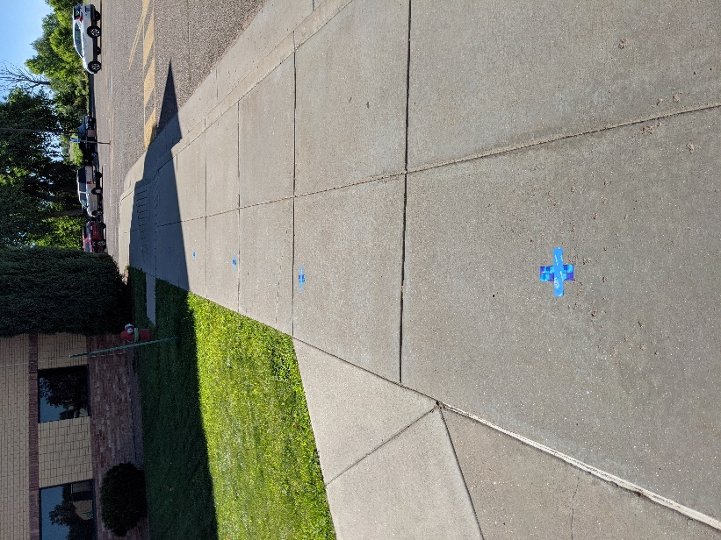

They will identify any individuals who are vulnerable to Covid-19 (as defined by the Governor in his general Covid-19 order) and offer them the opportunity to reschedule their jury service. They will also identify anyone who is living with or caring for any individuals who are vulnerable to Covid-19 and offer them the opportunity to reschedule their jury service. Those in the vulnerable population will not automatically be excused from jury duty, but they will be allowed to reschedule if they choose. A poster-board will be set up with a questionnaire to assist staff in identifying those that need a postponement. See Exhibit B, Juror Questionnaire.

The Jury Commissioner will also ensure that every summoned citizen has a mask or face shield. She will provide masks for those without one. She will explain that all summoned citizens must wear their masks or face shields whenever they are inside the courthouse and must maintain six feet of distance between themselves and any other person.

Potential Jurors will then wait on X marks to be admitted into Courtroom 101. This is on the main floor of the building, so no elevators will need to be used. When admitted to the courtroom, potential jurors will be randomly seated on an X.

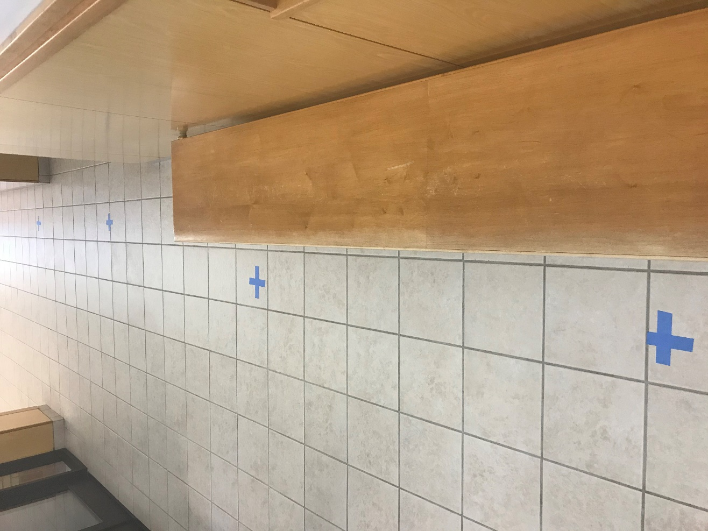

- Jury Selection

We will have spaced seating for a jury panel of twenty-two to twenty-four people, depending on use of the jury box. Counsels’ tables will be turned so that they do not have their backs to the jury pool during jury selection.

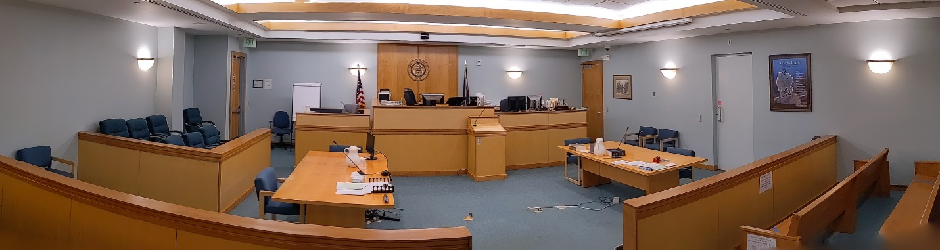

Everyone in courtroom 101 will maintain six-foot social distancing, including the defendant, attorneys, jurors, judge, bailiff, staff, court reporter, and, if the defendant is in custody, Sheriff’s deputies.

Judges will use Webex to provide online accessibility to the proceedings to members of the public who do not wish to come into the courthouse. For cases that might generate particular interest, the accommodation of Webex screened into an unused courtroom is also an option. Once a jury is seated, public access to the courtroom will be easier to accommodate. If the jury box is not used for potential jurors (one party would potentially have their back to the jury box), two members of the public could be seated there with a six-foot distance.

The judge will spend approximately 20-30 minutes conducting the initial introduction and jury qualification process. The judge will not be required to wear a mask during this process, as long as he/she is at least six feet away from everyone else.

From their tables, the attorneys will conduct their questioning of the panel. The judge and attorneys will use a microphone to amplify their voices. Parties each have their own microphones at counsel’s table.

Pursuant to guidance received from the Public Health Officials, attorneys speaking during voir dire will not be required to wear their mask, nor will jury panel members when answering any questions, as long as all are six feet from everyone else while speaking. Masks will need to be replaced when not speaking.

For-cause challenges and rulings shall be conducted with the white noise machine on and the parties at a six-foot distance in the well, or via email, by agreement of the parties and Court.

For the county court cases, it is reasonably foreseeable that a jury of 6 can be assembled from a pool of twenty-two to twenty-four people. In the 12-month period preceding the pandemic, the County Court Judge presided over twenty-two jury trials and does not recall a single trial necessitating over twenty-two people in order to select a jury.

For district court cases, a second venire would be summoned for 1 p.m. that same day. The check-in process will be the same as for the first venire. If the first venire is still in the courtroom, the second will be escorted to the 2nd floor extra space for assembly and randomization. We will have chairs spaced six feet apart. The extra space can hold thirty-six people at a six-foot distance, although only approximately thirty jurors would be seated there. The second venire will remain in the extra space until called for by the judge. Although the space is not finished, the Court Executive has consulted with the Fire Department. Additional lighting and lighted exit signs will be installed prior to use.

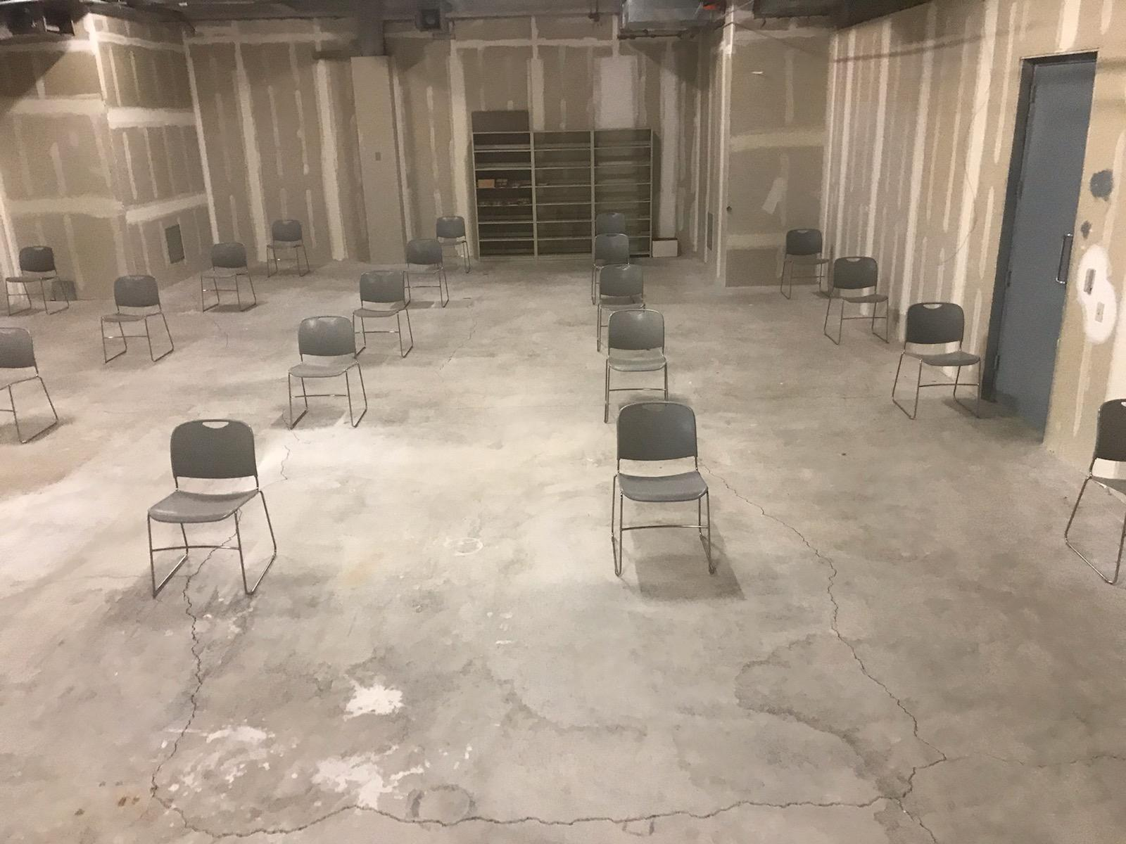

- TRIAL

When the jury selection process is completed, the case will proceed to trial. Jurors will remain in the gallery in their assigned seat, according to the random list. The parties will remain oriented so as to be able to speak towards the jury during the trial.

At this point, there will be room in the gallery for more members of the public, 16 for county court cases with no alternate juror, and 10 for district court trials with no alternates. These persons will also be required to maintain social distancing and wear masks. The judge may choose to use Webex to provide online accessibility for the proceedings to members of the public who do not wish to come inside the courthouse.

Everyone in the courtroom shall always maintain six-foot distancing and wear masks, except when speaking where there is a six-foot distance.

In order to allow for identification of the defendant, at the appropriate time, all persons in the courtroom will remove their face masks for a period of 10 seconds. Then masks will be replaced. This process will be used unless the parties stipulate to identification or agree to an alternate procedure.

The witness shall enter the courtroom and exit the courtroom wearing a mask. The witness will not wear a mask while on the stand unless all parties agree to the witness wearing a mask and he/she is six feet from anyone else. Between witnesses, the witness “stand” and microphone will be disinfected.

The attorney asking questions may remove his/her mask during questioning, with proper six-foot distancing.

The trial court will be strongly encouraged not to allow juror questions for witnesses.

Any item of evidence, whether it is formally admitted or not, shall only be handled by a person wearing rubber gloves. Jurors will be provided with gloves if receiving evidence.

Sidebars will be discouraged. Any sidebar will be conducted with the white noise machine on and the parties at a six-foot distance, or via email, as agreed upon by the parties.

During recesses, the jurors will remain in the courtroom and be escorted to the restroom by the bailiff as necessary. Outdoor breaks will be coordinated with the bailiff so as to avoid congestion in the halls or doorways. The Court and parties will leave the courtroom and may convene in the jury room if necessary. The jury room would support that reduced number of persons at a six-foot distance.

The courtroom will be fully cleaned during each lunch break and every evening, including the cleaning of every surface or thing touched that is not someone’s personal possession. Restrooms will be cleaned frequently.

The water fountain will be taped off, but bottled water will be provided.

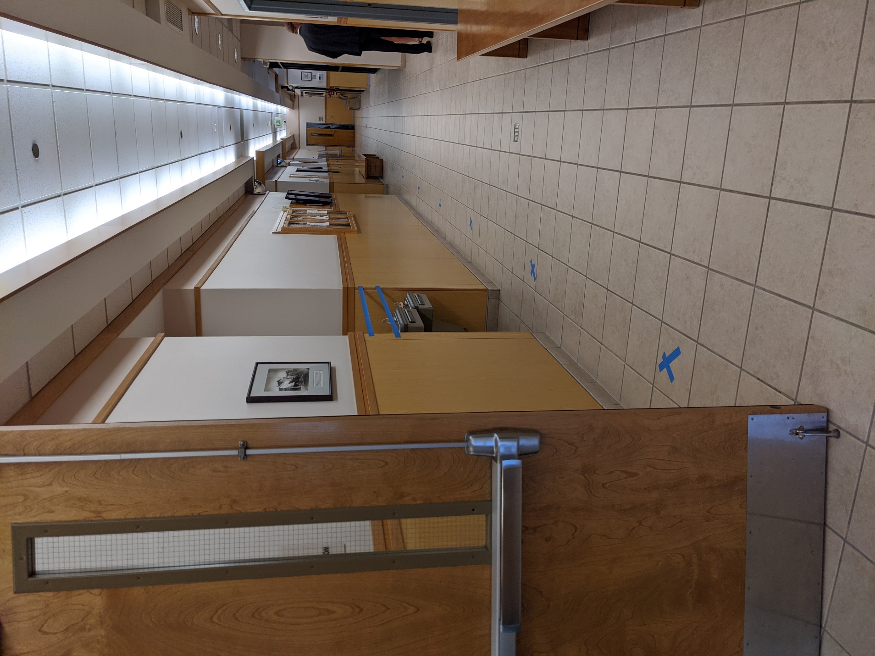

- JURY DELIBERATIONS

When closing arguments are completed and all jury instructions read by the judge, the jurors will remain in the courtroom for their deliberations. Everyone else will leave the courtroom, and the division CJA/bailiff will ensure no one enters the courtroom while the jury is deliberating. Signs will also be placed on the courtroom door and hallway doors to the courtroom indicating the jury is deliberating.

If the defendant is in custody, s/he will be escorted into and out of the courtroom by the secured door also used by the judge and court staff, and escorted into holding from that hallway rather than directly from the courtroom.

The jurors will be admonished that they must maintain six-foot social distancing at all times during deliberation, that they are encouraged to keep their masks on when not speaking, and that no piece of evidence may be handled without that juror wearing rubber gloves, which will be available in the courtroom during deliberations.

The bailiff will be available outside the doors to assist the jury. The court will order the bailiff to periodically, but at least once an hour, knock on the door and remind the jurors of the court’s order that they comply with CDC guidelines, including mask-wearing and social distancing.

Any food provided to the jury during deliberations shall be individually packaged for each juror.

In the event of jury questions, the parties can assemble safely at a six-foot distance in the jury room. The system microphone would be utilized in order to make a record.

Any post-verdict discussions between the judge, jury, and attorneys shall occur in the courtroom with proper social distancing and mask-wearing when not speaking.

