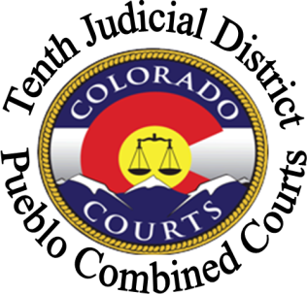
PUEBLO COMBINED COURTS

Judicial Officers Who Perform Wedding Ceremonies

Before contacting a judicial officer to arrange a ceremony you must have a marriage license. To obtain a marriage license contact the Pueblo County Clerk and Recorder’s Office, located in the Pueblo County Courthouse, 215 W. 10th Street, Pueblo, Colorado 81003, (719) 583-6507 during the hours of 8:00 am to 4:00 pm, or visit the web site at www.co.pueblo.co.us/clerk/recording.
Judicial officers charge a fee of $25.00 to perform a wedding ceremony at the Pueblo County Judicial Building, 501 N. Elizabeth, Pueblo, Colorado 81003 during regular business hours. For a ceremony outside of regular business hours and/or at an alternate location there may be an additional charge. Payment must be in cash and exact change is appreciated.
All wedding ceremonies are performed by appointment only. Contact judicial staff at the numbers below to make an appointment with a judicial officer to perform a wedding ceremony.

Judicial Officer | Staff Contact
Judge Deborah Eyler (does not perform ceremonies outside the Judicial Building or on weekends) | (719) 404-8970
Judge Victor Reyes | (719) 404-8838
Magistrate Dorothy Radakovich | (719) 404-8818
Magistrate Joyce Cohen (Monday-Thursday only) | (719) 404-8822
Magistrate Kelle Thomas (Wednesday-Friday only) | (719) 404-8882

