8th Judicial District Self-Help Center
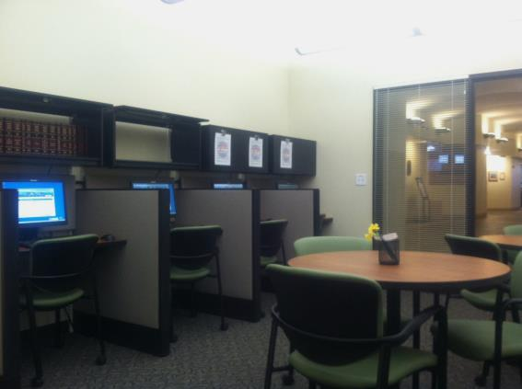
The Self-Help Center will be extending its hours of operation and services in Loveland beginning Thursday, January 22, 2015. The hours of operation will be the 2nd and 4th Thursday of each month from 1:30 p.m. to 4:30 p.m. The Self-Help Center will be available to assist self-represented parties involved in legal proceedings in the 8th Judicial District and will provide parties without attorneys free procedural information and will also assist in completing forms. The staff can answer questions about forms, the legal system, court procedure and court processes but CANNOT provide legal advice. Public access computers are available for research and completing forms. This center will be located in the Loveland Jury Assembly Room in the Loveland County Courthouse located at 810 E 10th Street Loveland, CO.

How can the Self-Help Center help you?
Here are just a few ways the Self-Help Center can provide assistance to self-represented individuals:
We Can…
Locate and Access Forms
Look Up Orders
Check Your Case Status
Assist you with Filling Out Forms
Determine Which Form You May Need
Check Forms for Completeness
Provide General Information About Court Procedure

Self-Help Personnel are neutral information providers and will provide the same services and information to all parties in a case, if requested. In all cases, it is best to obtain the assistance of your own lawyer, especially if your case contains significant or complicated issues.

