How to Join Denver Probate Court’s Virtual Courtrooms

The Virtual Courtrooms use the Cisco Webex platform. To refer to Cisco’s own directions for joining a Webex meeting, or to perform a test meeting on your device, visit their website at www.webex.com. You may also access the Court’s online training module at: https://www.courts.state.co.us/Self_Help/VirtualSessions/story.html.
You can create an account by going to https://www.webex.com/pricing/index.html and selecting “Sign Up” for a free account. If you do not want to create an account, you can just download the software (also free) at https://www.webex.com/downloads.html
- Appearing By Video (Preferred)
- If appearing by video, you will need to join from a computer or tablet equipped with a Webcam and speaker, or from your smart phone, using the Webex App free download.

- To join a DPC Virtual Courtroom from the Webex App, enter the relevant meeting code (listed below), into the “Join a Meeting” field and click the “Join” button.

Courtroom 224 Meeting Number: 922 879 992 (https://judicial.webex.com/join/Courtroom224)
Courtroom 300 Meeting Number: 920 159 400 (https://judicial.webex.com/join/courtroom300)

- Make sure both your microphone and video icons are turned on, and double check that “Use computer for audio” is selected in the preview screen. Once in the meeting, please mute your microphone if you are not speaking to reduce feedback for other participants.
- To leave the meeting, click the “Leave Meeting” button (the red circle with the white “X”) in your tools at the bottom of the screen and select “Leave Meeting.”
Below is a guide for the icons that appear at the bottom of your screen:
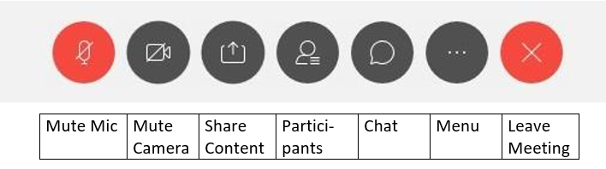

- Appearing by Telephone
  - If you do not have a device with a camera, or your device stops working during a hearing, you may also join the meeting by calling: 720-650-7664 (Please do not use speakerphone).
  - You will then be prompted to enter a meeting number or access code, which will depend on the Courtroom the hearing is being held in:

Courtroom 224 Meeting Number: 922 879 992
Courtroom 300 Meeting Number: 920 159 400
  - If the host has started the meeting, you’ll be immediately looped in. If the meeting has not been started, you will be on hold.
  - If prompted for an “Attendee ID,” simply press the # key.

