The 8th Judicial District Ask-A-Lawyer Clinic will be held on the 2nd Tuesday of every month from 3:00 pm – 5:00 pm at the Self-Help Center located on the first floor of the Larimer County Justice Center. The Clinic allows self-represented parties the opportunity to meet with an attorney for 15 minutes to have their legal questions answered for free. You can sign up for an appointment in person at the Self Help Center or by emailing [08selfhelp@judicial.state.co.us](mailto:08selfhelp@judicial.state.co.us).

**Ask-a-Lawyer clinics begin Tuesday, October 14th from 3:00 pm – 5:00 pm. Sign up soon to set an appointment.**

### Located at the Self Help Center on the

### 1st floor of the Larimer County Justice Center, 201 Laporte Avenue, 1st Floor Fort Collins, CO 80521

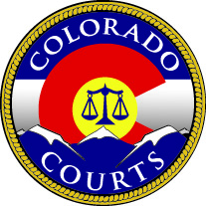

## Ask-a-Lawyer Clinics: 2nd Tuesday

## of every month from

## 3:00 pm to 5:00 pm

**Get your legal questions answered!**

MC900151293[1]

# Ask-A-Lawyer Clinic