

***Judicial Department***

***FY 2015-16 Performance Report***

The Judicial Department (“Department”) consists of the Colorado Supreme Court, Colorado Court of Appeals, trial courts, probation, and the State Court Administrator’s Office. The Department strives to protect constitutional and statutory liberties; assure equal access; provide fair, timely, and constructive resolution of cases; enhance community welfare and public safety; supervise offenders; and facilitate victim and community reparations. Article VI of the Colorado Constitution and section 13-4-101, C.R.S. (2014) provide the constitutional and statutory authority for the state courts. Sections 18-1.3-201 and 18-1.3-202, C.R.S. (2014) provide the statutory authority for probation.

The Department developed the following five principle strategies to meet the priorities of the Department:

1. Provide equal access to the legal system and give all an opportunity to be heard;
2. Treat all with dignity, respect, and concern for their rights and cultural backgrounds, and without bias or appearance of bias;
3. Promote quality judicial decision-making and judicial leadership;
4. Implement quality assessments and community supervision of adult and juvenile probationers to demonstrably enhance public safety and respect for victim rights; and
5. Cultivate public trust and confidence through the thoughtful stewardship of public resources.

The Department has also identified three major performance measures to gauge our success in implementing the five principle strategies. The three major performance measures include: (1) access and fairness surveys; (2) time standards for district and county courts; and (3) Probation client success rates. The Department regularly evaluates these performance measures, and the following three pages illustrate our most recent evaluation of the measures. In addition, the Department’s performance plan can be found at:

<http://www.courts.state.co.us/Administration/Division.cfm?Division=pa>

*Performance* *Measure*

***Access and Fairness surveys*** continue to be conducted throughout the State to assess ratings of court users on the court’s accessibility and its treatment of customers in terms of fairness, equality, and respect. This measure provides a tool for surveying all court users about their experience in the courthouse. Comparison of results by location and district assist in informing court management practices. To date, over 15,000 court users statewide have responded to these surveys.

*Performance* *Measure*

Performance goals for Courts and Probation have been established through various means, including Chief Justice Directive 08-05 (Case Management Standards). This directive was developed with input from judges and establishes aspirational time processing goals for each case class. Information about each district’s progress in meeting the goals is reported quarterly. Information for individual judges is provided to the Judicial Performance Commission during each judge’s retention evaluation. The tables below reflect the ***Time Standards for District and County courts.***

|  |  |  |  |
| --- | --- | --- | --- |
| **TABLE 1** | | | |
| **District Court Case Management Time Standards** | | | |
| **Established Pursuant CJD 08-05** | | | |
| **Case Class** | **Pending Cases Exceeding Target** | | **Target** |
| **1st Quarter FY 2013** | **4th Quarter FY 2014** |
| Civil | 16.8% | 13.7% | No more than 10% of cases open more than one year. |
| Criminal | 6.6% | 4.9% | No more than 5% of cases open more than one year. |
| Domestic Relations | 5.4% | 3.3% | No more than 5% of cases open more than one year. |
| Juvenile Delinquency | 4.7% | 1.7% | No more than 5% of cases open more than one year. |
| Dependency and Neglect (over 6 years old)* | 6.7% | 4.4% | No more than 5% of cases open more than 18 months |
| Dependency and Neglect (under 6 years old)* | 9.4% | 7.6% | No more than 10% of cases open more than one year. |
| Due to data conversion from BRIO to COGNOS, FY13 results are not available for 2nd thru 4th quarters.  * The standards in dependency and neglect are under review. This measure shows time to first permanency hearing. | | | |
| A more optimal measure would be time to true permanent placement or termination of court jurisdiction. | | | |

|  |  |  |  |
| --- | --- | --- | --- |
| **TABLE 2** | | | |
| **County Court Case Management Time Standards** | | | |
| **Established Pursuant CJD 08-05** | | | |
| **Case Class** | **Pending Cases Exceeding Target** | | **Target** |
| **1st Quarter**  **FY 2013** | **4th Quarter**  **FY 2014** |
| Civil | 6.4% | 5.3% | No more than 5% of cases open more than six months. |
| Misdemeanor | 13.6% | 11.3% | No more than 10% of cases open more than six months. |
| Small Claims | 6.4% | 4.1% | No more than 1% of cases open more than six months. |
| Traffic | 6.8% | 4.7% | No more than 5% of cases open more than six months. |
| DUI/DWAI | 14.4% | 12.7% | No more than 20% of cases open more than seven months. |
| Due to data conversion from BRIO to COGNOS, FY13 results are not available for 2nd thru 4th quarters. | | | |

*Performance* *Measure*

One of the main goals of ***probation*** is to effect long term behavior change. By focusing on issues that relate to criminal behavior, probation officers can increase the likelihood that adults and juveniles placed on probation will make lasting, pro-social behavior change. Measuring outcomes and providing feedback is a critical piece of implementing efficient and effective practices in probation.

C:\STOCKLAYOUTS\CURRENT PROJECTS\FN99803-PL\FN99803-IMG10.emf

|  |  |  |  |
| --- | --- | --- | --- |
| **Colorado State Probation Success Rates** | | | |
| Program  This chart provides feedback for one measurement of performance: successful completion of probation. The chart lists the statewide success rates, and the percentage and actual number of terminations for FY 2013 and FY 2014.  Note: intensive program terminations include those cases terminated directly from the program as well as those probationers who completed the program and are transitioning from the intensive program to regular supervision. Due to the small number of probationers in some programs, success rates may experience fluctuations. | FY 2013 Statewide | FY 2014 Target | FY 2014 Statewide |
| Regular Adult | **66% (14,151)** | 70% | **65% (14,628)** |
| Adult Intensive Supervision Program | **61% (673)** | 68% | **62% (657)** |
| Female Offender Program | **66% (101)** | 72% | **65% (114)** |
| Sex Offender Intensive Supervision Program | **45% (176)** | 44% | **47% (131)** |
| Regular Juvenile | **72% (2,517)** | 76% | **73% (2,302)** |
| Juvenile Intensive Supervision Program | **45% (144)** | 50% | **46% (147)** |

C:\STOCKLAYOUTS\CURRENT PROJECTS\FN99803-PL\FN99803-IMG10.emf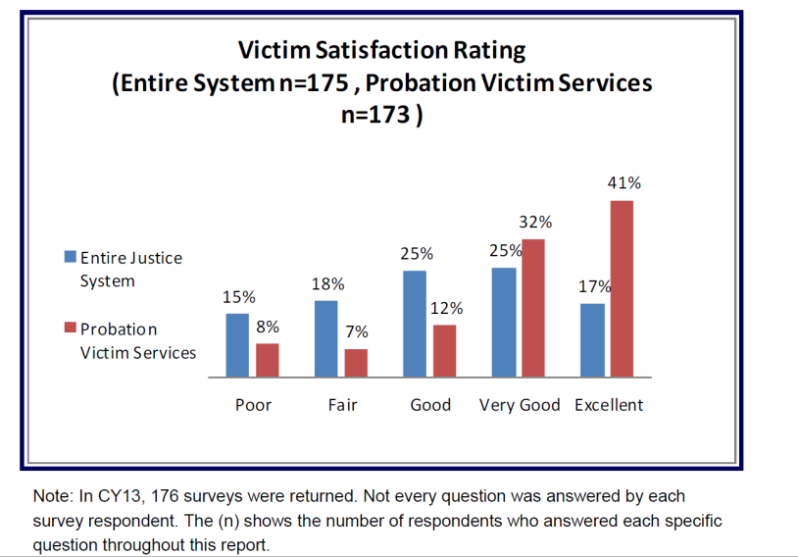

When the probationer’s case is terminating, Victim Services Officers send out a victim satisfaction survey to victims who have requested notification of probation status.  Each calendar year the results are compiled into a statewide report. Options to automate the survey are currently being reviewed. The results shown include the victims’ responses regarding Probation’s performance and the performance of other criminal justice agencies.

When the probationer’s case is

terminating, Victim Services Officers send out a victim satisfaction survey to victims who have requested

notification of probation status.

Each calendar year the results are compiled into a statewide report. Options to automate the survey are currently being reviewed. The

results shown include the victims’ responses regarding Probation’s

performance and the performance of other criminal justice agencies.

When the probationer’s case is

terminating, Victim Services Officers send out a victim satisfaction survey to victims who have requested

notification of probation status.

Each calendar year the results are compiled into a statewide report. Options to automate the survey are currently being reviewed. The

results shown include the victims’ responses regarding Probation’s

performance and the performance of other criminal justice agencies.

When the probationer’s case is

terminating, Victim Services Officers send out a victim satisfaction survey to victims who have requested

notification of probation status.

Each calendar year the results are compiled into a statewide report. Options to automate the survey are currently being reviewed. The

results shown include the victims’ responses regarding Probation’s

performance and the performance of other criminal justice agencies.